

AUTOMATION CONTROL LAB

PROCESS INSTRUMENTATION TECHNOLOGY

STUDENT MANUAL

**AUTOMATION CONTROL LAB**

In this lab we use different types of Automation and control techniques, we will work on the different applications according to real-time industry scenarios. Understand the role of programmable logic controllers in complex mechatronic systems, modules, and subsystems.



The list of courses offered,

|  |  |  |
| --- | --- | --- |
| **S.No** | **Name of the Course** | **Duration** |
| **1** | Basics of PLC | 50 Hours |
| **2** | Basic SCADA | 50 Hours |
| **3** | Industrial Level control and Batch Process Reactor System | 30 Hours |
| **4** | Process Instrumentation Technology | 30 Hours |
| **5** | Advance Process Control Techniques | 40 Hours |
| **6** | Advanced Industrial Electro-Pneumatic System | 40 Hours |
| **7** | Industrial Electro-Hydraulic System | 40 Hours |

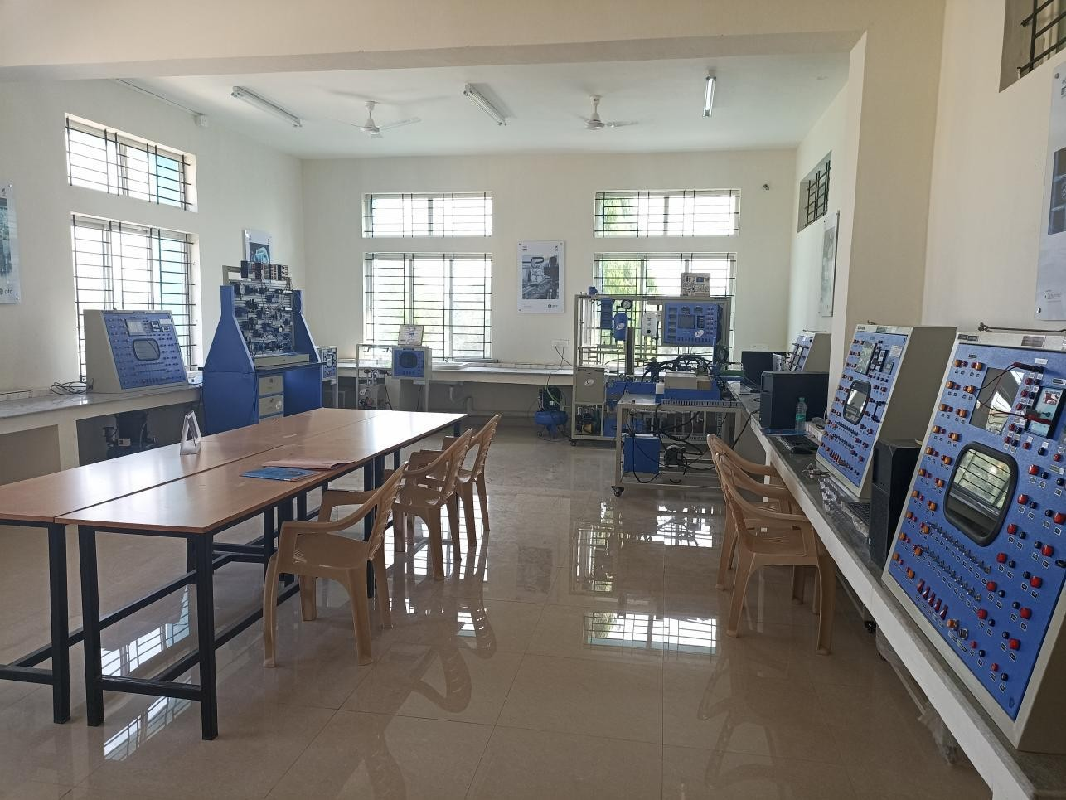

AUTOMATION CONTROL

LAB

**PROCESS INSTRUMENTATION TECHNOLOGY**

Process instrumentation technology course offered in Automation Control Lab. In this course you will be learning about instrumentation and its technology for measuring temperature, pressure,level & flow etc. You will also learn about sensor transducer, transmitter ( For measuring temperature, pressure,level & flow) & smart positioner.

|  |  |  |
| --- | --- | --- |
| **S. No** | **Name of the Course** | **Duration** |
| **4** | Process Instrumentation Technology | 30 Hours |

##### Hardware equipped

*PC-PLC BASED MULTIPROCESS KIT*

Table of Contents

Basics of process instruments 5

What is Process Control? 5

Types of processes using process control 6

Why Process Control is required? 7

Maintain the process at the operational conditions and set points 7

Transition the process from one operational condition to another 7

Components of Process Control 8

What is Instrumentation? Measurement and Instrumentation 8

Importance of process parameters: 9

What is closed-loop control technology? 11

What is a system? 12

Open-loop and closed-loop control 12

Open loop Control System 13

Close loop Control System 13

Application in various Process Industries 14

Fundamentals of Sensor, Transducer and Transmitter 17

Types of Transducers 17

What is S.M.A.R.T? Configuration, Signal Conditioning, Self-Diagnosis 18

Measuring signal types: Digital and Analog 19

Digital 19

Analog 20

Standard Instrumentation signals, Different current ranges 21

The Live Zero-Based Control Signal 22

Instrument properties effect on process 23

Instrument noise 24

Pressure measurements 25

What is Pressure? 25

Units for pressure measurements 26

Types of Pressure measurements 27

Gauge (G) 27

Sealed (S) 27

Absolute (A) 27

Differential (D) 27

Bourdon tube 28

Principle 28

Working 29

Advantages 30

Disadvantages 30

Usage example 30

Diaphragm 31

Manometer 32

Usage examples 34

Advantages 34

Disadvantages 35

Piezo resistive 35

Application area 35

Advantages 36

Capacitance 36

Usage examples 37

Strain Gauge 37

Usage examples 38

Vibrating Wire 38

Linear Variable Differential Transformer (LVDT) 39

Operation 40

Optical 41

Temperature measurement 42

What is Temperature: Units for temperature measurements 42

Resistance Temperature Detectors (RTD) 42

RTD Structure 43

Common Metal Temperature and Resistance Ranges 44

Thermocouples 45

Thermocouple Structure 45

Common Metal Temperature and EMF Values 46

Laws for thermocouples 48

Application 48

Thermistor 49

Applications 50

Infrared Pyrometer 51

Infrared Thermometer Principle 52

Advantages 52

RTD (2 Wire, 3 Wire and 4 Wire) connections 52

Two Wire RTD 53

1. WIRE BRIDGE 53
2. Wire RTD 54

3-Wire Bridge Measurement Errors 55

Applications of Temperature Measurement 56

Level Measurement 57

Level measurement 57

Types of Level Measurements 57

Point Level Measurements 57

Continues Level Measurements 57

Different Measuring Techniques 58

Level gauges (sight glasses) 59

Float And tape 60

Plumb Bob 61

Hydrostatic pressure 61

Displacement level measurements 63

Torque tubes 63

Ultrasonic level measurement 64

Bubbler level measurement 64

Electromagnetic Level Measurement 65

Echo technology 65

Radar level measurement 66

Laser level measurement 67

Optical level measurements 68

Weight base level Measurement 69

Capacitive Level Measurement 70

Inductive level measurement 70

Flow Measurement 71

Flow measurement 71

Units of Flow Measurement 71

Factor Affecting on Flow Measurement 71

Types of Flow 73

Types of Flow Measurement devices 74

Rotary Piston Meter 74

Variable Area Flow meters 75

Coriolis Single Bent Tube 76

Magnetic Inductive AC 77

Ultrasonic Doppler 78

Effective Pressure 80

Application of Flow Measurements 80

Communication Protocol 82

Profibus 82

Origin 82

Profibus DP 82

Profibus PA 82

HART Communications Protocol 83

Modes 84

Foundation Fieldbus 84

CAN open 85

Profinet 85

Simatic PDM software 87

Siemens SIMATIC PDM (Process Device Manager) 87

EDD File 87

Field device configuration steps in Simatic PDM 87

Steps for HART protocol based devices 87

Steps for PA protocol based device 88

Basics of process instruments What is Process Control?

Process control is extensively used in industry and enables mass production of consistent

products from continuously operated processes such as oil refining, paper manufacturing, chemicals, power plants and many others. Process control enables automation, by which a small staff of operating personnel can operate a complex process from a central control room. A common misconception in process control is that it is all about the controller – that you can force a particular process response just by getting the right tuning parameters.

In reality, the controller is just a partner. A process will respond to a controller’s commands only in the manner which it can. To understand process control you must understand the other partners as well: sensors, final control elements and the process itself. All of these determine what type of response the controller is capable of extracting out of the process. It is not the other way aroundProcess control is an engineering discipline that deals with architectures, mechanisms and algorithms for maintaining the output of

Specific process within a desired range. For instance, the temperature of a chemical reactor may be controlled to maintain a consistent product output. Process control is extensively used in industry and enables mass production of consistent products from continuously operated processes such as oil refining, paper manufacturing, chemicals, power plants and many others. Process control enables automation, by which a small staff of operating personnel can operate a complex process from a central control room.

Process control may either use feedback or it may be open loop. Control may also be continuous (automobile cruise control) or cause a sequence of discrete events, such as a timer on a lawn sprinkler (on/off) or controls on an elevator (logical sequence).A thermostat on a heater is an example of control that is on or off. A temperature sensor turns the heat source on if the temperature falls below the set point and turns the heat source off when the set point is reached. There is no measurement of the difference between the set point and the measured temperature (e.g. no error measurement) and no adjustment to the rate at which heat is added other than all or none.

A familiar example of feedback control is cruise control on an automobile. Here speed is the measured variable. The operator (driver) adjusts the desired speed set point (e.g. 100 km/hr.) and the controller monitors the speed sensor and compares the measured speed to the set point. Any deviations, such as changes in grade, drag, wind speed or even using a different grade of fuel (for example an ethanol blend) are corrected by the controller making a compensating adjustment to the fuel valve open position, which is the manipulated variable. The controller makes adjustments having information only about the error (magnitude, rate of change or cumulative error) although settings known as *tuning* are used to achieve stable control. The operation of such controllers is the subject of control theory.

A commonly used control device called a programmable logic controller, or a PLC, is used to read a set of digital and analog inputs, apply a set of logic statements, and generate a set of analog and digital outputs. For example, if an adjustable valve were used to hold level in a tank

the logical statements would compare the equivalent pressure at depth set point to the pressure reading of a sensor below the normal low liquid level and determine whether more or less valve opening was necessary to keep the level constant. A PLC output would then calculate an incremental amount of change in the valve position. Larger more complex systems can be controlled by a Distributed Control System (DCS) or SCADA system.

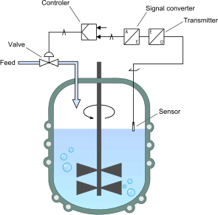

# Types of processes using process control

Processes can be characterized as one or more of the following forms:

* **Discrete** – Found in many manufacturing, motion and packaging applications. Robotic assembly, such as that found in automotive production, can be characterized as discrete process control. Most discrete manufacturing involves the production of discrete pieces of product, such as metal stamping.
* **Batch** – Some applications require that specific quantities of raw materials be combined in specific ways for particular durations to produce an intermediate or end result. One example is the production of adhesives and glues, which normally require the mixing of raw materials in a heated vessel for a period of time to form a quantity of end product. Other important examples are the production of food, beverages and medicine. Batch processes are generally used to produce a relatively low to intermediate quantity of product per year (a few pounds to millions of pounds).
* **Continuous** – Often, a physical system is represented through variables that are smooth and uninterrupted in time. The control of the water temperature in a heating jacket, for example, is an example of continuous process control. Some important continuous processes are the production of fuels, chemicals and plastics. Continuous processes in

manufacturing are used to produce very large quantities of product per year (millions to billions of pounds).

Applications having elements of discrete, batch and continuous process control are often called ***hybrid*** applications.

# Why Process Control is required?

Process control refers to the way in which manufacturers, companies and producers maintain a tight control over the various components and steps involved in the production of final good or service. The importance of process control lies in the value of such a process to the various businesses through the increase in quality of their products and the reduction of mishaps that would likely occur without the application of process control. Since customers also judge a company by the quality of their products and services, process control helps ensure that companies maintain a loyal customer base.

An importance of process control is derived from the way in which a strict adherence to process control helps a company avert potentially costly mistakes. Considering the fact that process control requires a complete monitoring of the various components of the production process, any potential problem will be spotted early on in the production process, before it becomes a significant problem later. This importance of process control can be seen in the case of a company that makes clothes. Assuming one of the machines used in stitching the clothes malfunctions and causes some defects in the stitches, the process control will allow the organization to fix this problem early on instead of later when it will be costlier.

A control system is required to perform either one or both task:

### Maintain the process at the operational conditions and set points

Many processes should work at steady state conditions or in a state in which it satisfies all the benefits for a company such as budget, yield, safety, and other quality objectives. In many real- life situations, a process may not always remain static under these conditions and therefore can cause substantial losses to the process. One of the ways a process can wander away from these conditions is by the system becoming unstable, meaning process variables oscillate from its physical boundaries over a limited time span. An example of this would be a water tank in a

Heating and cooling process without any drainage and is being constantly filled with water. The water level in the tank will continue to rise and eventually overflow. This uncontrolled system can be controlled simply by adding control valves and level sensors in the tank that can tell the engineer or technician the level of water in the tank. Another way a process can stray away from steady state conditions can be due to various changes in the environmental conditions, such as composition of a feed, temperature conditions, or flow rate.

### Transition the process from one operational condition to another

In real-life situations, engineers may change the process operational conditions for a variety of different reasons, such as customer specifications or environment specifications. Although, transitioning a process from one operational condition to another can be detrimental to a process, it also can be beneficial depending on the company and consumer demands.

Examples of why a process may be moved from one operational set point to another:

* + Economics
  + Product specifications
  + Operational constraints
  + Environmental regulations
  + Consumer/Customer specifications
  + Environmental regulations
  + Safety precautions

# Components of Process Control

A controller seeks to maintain the measured process variable (PV) at set point (SP) in spite of unmeasured disturbances (D). The major components of a control system include a sensor, a controller and a final control element. To design and implement a controller, we must:

* + Have identified a process variable we seek to regulate, be able to measure it(or something directly related to it) with a sensor, and be able to transmit that measurement as an electrical signal back to our controller, and
  + Have a **final control element (FCE)** that can receive the controller output (CO) signal, react in some fashion to impact the process (e.g., a valve moves), and as a result cause the process variable to respond in a consistent and predictable fashion.

# What is Instrumentation? Measurement and Instrumentation

**Instrumentation** is the variety of measuring instruments to monitor and control a process. It is the art and science of measurement and control of process variables within a production, laboratory, or manufacturing area.

An instrument is a device that measures a physical quantity such as flow, temperature, level, distance, angle, or pressure. Instruments may be as simple as direct reading thermometers or may be complex multi-variable process analyzers. Instruments are often part of a control system in refineries, factories, and vehicles. The control of processes is one of the main branches of applied instrumentation. Instrumentation can also refer to handheld devices that measure some desired variable. Diverse handheld instrumentation is common in laboratories, but can be found in the household as well. For example, a smoke detector is a common instrument found in most western homes.

Instruments attached to a control system may provide signals used to operate solenoids, valves, regulators, circuit breakers, or relays. These devices control a desired output variable, and provide either remote or automated control capabilities. These are often referred to as final control elements when controlled remotely or by a control system. A transmitter is a device that produces an output signal, often in the form of a 4 20 mA electrical current signal, although many other options using voltage, frequency, pressure, or Ethernet are possible.

This signal can be used for informational purposes, or it can be sent to a PLC, DCS, SCADA system, Lab VIEW or other type of computerized controller, where it can be interpreted into readable values and used to control other devices and processes in the system.

Control instrumentation plays a significant role in both gathering information from the field and changing the field parameters, and as such are a key part of control loops.

# Importance of process parameters:

* **Process Parameters** (also called a process variable) are certain measures that refer to status of the process (their values indicate whether the process meets the plan or it needs adjustment). In order to obtain effective execution of the process its parameters should stay under continuous control.

The simplest examples of parameters you can find in a manufacturing process are pressure, temperature, and chemical composition – anyone of these may have its desired value that is called a set-point that regulates proper functioning of process elements and operations, while if a parameter deviates from its set-point (goes beyond the acceptable level of variance), then probably a process tends to fail, hence special automatics or human operators should intrude into this process to adjust it and prevent upset.

Process parameters are extremely important in controlling a process, therefore should be accurately measured and monitored throughout process run – it is an essential part of process management and maintenance of its efficiency, therefore process parameters, as dynamically changeable features, are controlled with a help of technological sensors mounted at critical areas of a process, along with implementation of special methods and equipment to adjust them.

The Process Variables used in instrumentation are:

* + **Flow** - Defined as volume per unit of time at specified temperature and pressure conditions, is generally measured by positive-displacement or rate meters. Units: kg

/ hr., litter / min, gallon / min, m3 / hr., Nm3 / hr. (gases)

* + **Pressure** - Force acting per unit Area. P = F/A. Units: bar, Pascal, kg / cm2, lb. / in2.
  + **Temperature** - It is the degree of hotness or coldness of a body. Units: Degree Centigrade, Degree Fahrenheit, Degree Kelvin, Degree Rankin.
  + **Level** - Different between two heights. Units: Meters, mm, cm, percentage.

## For an example: - Temperature Control

As shown below, the home heating control system described in this article can be organized as a traditional control loop block diagram. Block diagrams help us visualize the components of a loop and see how the pieces are connected.

A home heating system is simple on/off control with many of the components contained in a small box mounted on our wall. Nevertheless, we introduce the idea of control loop diagrams by presenting a home heating system in the same way we would a more sophisticated commercial control application.

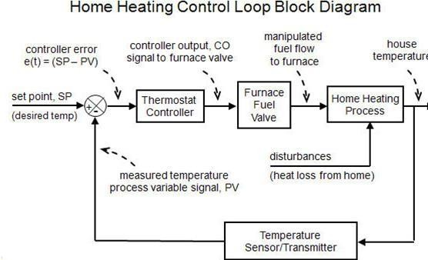

Starting from the far right in the diagram above, our process variable of interest is house temperature. A sensor, such as a thermistor in a modern digital thermostat, measures temperature and transmits a signal to the controller. The measured temperature PV signal is subtracted from set point to compute controller error, e (t) = SP – PV. The action of the controller is based on this error, e (t).

In our home heating system, the controller output (CO) signal is limited to open/close for the fuel flow solenoid valve (our FCE). So in this example, if e (t) = SP – PV > 0, the controller signals to open the valve. If e (t) = SP – PV < 0, it signals to close the valve. As an aside, note that there also must be a safety interlock to ensure that the furnace burner switches on and off as the fuel flow valve opens and closes. As the energy output of the furnace rises or falls, the temperature of our house increases or decreases and a feedback loop is complete. The important elements of a home heating control system can be organized like any commercial application:

* + Control Objective: maintain house temperature at SP in spite of disturbances
  + Process Variable: house temperature
  + Measurement Sensor: thermistor; or bimetallic strip coil on analog models
  + Measured Process Variable (PV) Signal: signal transmitted from the thermistor
  + Set Point (SP): desired house temperature
  + Controller Output (CO): signal to fuel valve actuator and furnace burner
  + Final Control Element (FCE): solenoid valve for fuel flow to furnace
  + Manipulated Variable: fuel flow rate to furnace
  + Disturbances (D): heat loss from doors, walls and windows; changing outdoor temperature; sunrise and sunset; rain…

## A General Control Loop and Intermediate Value Control

The home heating control loop above can be generalized into a block diagram pertinent to all feedback control loops as shown below.

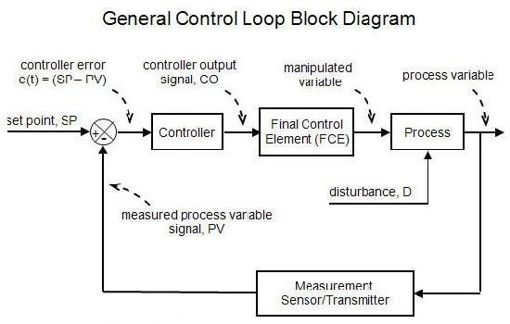

Both diagrams above show a closed loop system based on negative feedback. That is, the controller takes actions that counteract or oppose any drift in the measured PV signal from set point.

# What is closed-loop control technology?

Variables such as pressure, temperature or flow-rate often have to be set on large machines or systems. This setting should not change when faults occur. Such tasks are undertaken by a closed-loop controller. Control engineering deals with all problems that occur in this connection. The controlled variable is first measured and an electrical signal is created to allow an independent closed-loop controller to control the variable. The measured value in the controller must then be compared with the desired value or the desired-value curve. The result of this comparison determines any action that needs to be taken. Finally a suitable location must be found in the system where the controlled variable can be influenced (for example the actuator of a heating system). This requires knowledge of how the system behaves. Closed- loop control technology attempts to be generic – that is, to be applicable to various technologies. Most text books describe this with the aid of higher mathematics. This chapter describes the fundamentals of closed-loop control technology with minimum use of mathematics.

In closed-loop control the task is to keep the controlled variable at the desired value or to follow the desired-value curve. This desired value is known as the reference variable. This problem occurs in many systems and machines in various technologies. The variable that is subject to control is called the controlled variable. Examples of controlled variables are:

Pressure in a pneumatic accumulator:

* + Pressure of a hydraulic press
  + Temperature in a galvanizing bath
  + Flow-rate of coolant in a heat exchanger Concentration of a chemical in a mixing vessel
  + Feed speed of a machine tool with electrical drive

# What is a system?

The controlled system has an input variable and an output variable. Its response is described in terms of dependence of the output variable on the input variable. These responses between one or several variables can normally be described using mathematical equations based on physical laws. Such physical relationships can be determined by experimentation. Controlled systems are shown as a block with the appropriate input and output variables



**Example:** a water bath is to be maintained at a constant temperature. The water bath is heated by a helical pipe through which steam flows. The flow rate of steam can be set by means of a control valve. Here the control system consists of positioning of the control valve and the temperature of the water bath. This result in a controlled system with the input variable "temperature of water bath" and the output variable "position of control valve"

The following sequences take place within the controlled system: The position of the control valve affects the flow rate of steam through the helical pipe.

* + The steam flow-rate determines the amount of heat passed to the water bath.
  + The temperature of the bath increases if the heat input is greater than the heat loss and drops if the heat input is less than the heat loss.
  + These sequences give the relationship between the input and output variables.

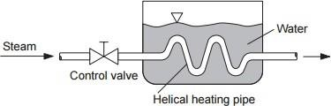

# Open-loop and closed- loop control

Having defined the term

"controlled system" it only remains to give definitions of closed-loop control as contained in

standards. First it is useful to fully understand the difference between open-loop control and closed-loop control.

### Open loop Control System

German standard DIN 19 226 defines open-loop control as a process taking place in a system where by one or more variables in the form of input variables exert influence on other variables in the form of output variables by reason of the laws which characterize the system. The distinguishing feature of open-loop control is the open nature of its action, that is, the output variable does not have any influence on the input variable

**Example:** Volumetric flow is set by adjusting a control valve. At constant applied pressure, the volumetric flow is directly influenced by the position of the control valve. This relationship between control valve setting and volumetric flow can be determined either by means of physical equation or by experiment. This results in the definition of a system consisting of the "valve" with the output variable "volumetric flow" and the input variable "control valve setting"

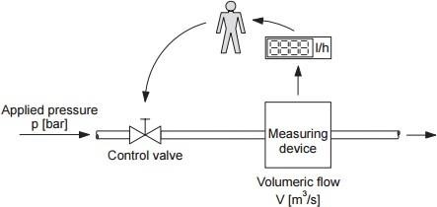

### Close loop Control System

DIN 19 226 defines closed-loop control as a process where the controlled variable is continuously monitored and compared with the reference variable. Depending on the result of this comparison, the input variable for the system is influenced to adjust the output variable to the desired value despite any disturbing influences. This feedback results in a closed-loop action. This theoretical definition can be clarified using the example of volumetric flow control.

**Example**: The volumetric flow (the output variable) is to be maintained at the predetermined value of the reference variable. First a measurement is made and this measurement is converted into an electrical signal. This signal is passed to the controller and compared with the desired value. Comparison takes place by subtracting the measured value from the desired value. The result is the deviation.

In order to automatically control the control valve with the aid of the deviation, an electrical actuating motor or proportional solenoid is required. This allows adjustment of the controlled variable. This part is called the manipulating element.

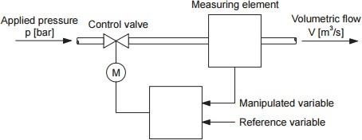

The controller now passes a signal to the manipulating element dependent on the deviation. If there is a large negative deviation that is the measured value of the volumetric flow is greater than the desired value (reference variable) the valve is closed further. If there is a large positive deviation, that is the measured value is smaller than the desired value, the valve is opened further.

Setting of the output variable is normally not ideal:

* + If the intervention is too fast and too great, influence at the input end of the system is too large. This results in great fluctuations at the output.
  + If influence is slow and small, the output variable will only approximate to the desired value.

In addition, different types of systems (control system) require different control strategy. Systems that respond slowly must be adjusted carefully and with forethought. This describes some of the control engineering problems faced by the closed-loop control engineer.

Design of a closed-loop control requires the following steps:

* + Determine manipulated variable (thus defining the controlled system)
  + Determine the behaviour of the controlled system
  + Determine control strategy for the controlled system (behaviour of the "controller" system)
  + Select suitable measuring and manipulating elements.

# Application in various Process Industries

##### General processes

These may be applied on their own, or as part of a larger process.

* + Liquefaction of gases - for ease of transportation
  + Supercritical drying, freeze-drying - removal of excess liquid
  + Scrubbing - removal of pollution from exhaust gases

##### Chemical processes

* + Haber process - chemically binding gaseous nitrogen from the atmosphere to make ammonia
  + Smelting - chemically enhancing metals
  + Disinfection - chemical treatment to kill bacteria and viruses
  + Pyro processing - using heat to chemically combine materials, such as in cement.

##### Heat processes

* + Flash smelting - a refinement on smelting, for sulphur-containing ores (produces copper, nickel and lead)3

##### Electrolysis

* + The availability of electricity and its effect on materials gave rise to several processes for plating or separating metals.
  + Gilding, Electroplating, Iodization, Electro winning - depositing a material on an electrode
  + Electro polishing - the reverse of electroplating
  + Electro focusing - similar to electroplating, but separating molecules
  + Electrolytic process - the generic process of using electrolysis
  + Electro phoretic deposition - electrolytic deposition of colloidal particles in a liquid medium
  + Electrotyping - using electroplating to produce printing plates
  + Metalizing, Plating, Spin coating - the generic term for giving non-metals a metallic coating

##### Cutting

* + Shearing
  + Sawing
  + Plasma cutting
  + Water-jet cutting
  + Oxyacetylene cutting
  + Electrical discharge machining (EDM)
  + Machining - the mechanical cutting and shaping of metal which involves the loss of the material
  + Laser cutting

##### Physical processes

There are several physical processes for reshaping a material by cutting, folding, joining or polishing, developed on a large scale from workshop techniques.

* + Forging - the shaping of metal by use of heat and hammer
  + Casting - shaping of a liquid material by pouring it into moulds and letting it solidify
  + Progressive stamping - the production of components from a strip or roll
  + Stamping
  + Hydro forming - a tube of metal is expanded into a mould under pressure
  + Sandblasting - cleaning of a surface using sand or other particles
  + Soldering, Brazing, Welding - a process for joining metals
  + Tumble polishing - for polishing
  + Precipitation hardening - heat treatment used to strengthen malleable materials
  + Work hardening - adding strength to metals, alloys, etc.
  + Case hardening, Differential hardening, Shot peening - creating a wear resistant surface
  + Die cutting - A "forme" or "die" is pressed onto a flat material in order to cut, score, punch and otherwise shape the material

##### Moulding

The physical shaping of materials by forming their liquid form using a mould.

* + Casting, Sand casting - the shaping of molten metal or plastics using a mould
  + Sintering, Powder metallurgy - the making of objects from metal or ceramic powder
  + Blow moulding as in plastic containers or in the Glass Container Industry - making hollow objects by blowing them into a mould.
  + Compression moulding

##### Physical processes

There are several physical processes for reshaping a material by cutting, folding, joining or polishing, developed on a large scale from workshop techniques.

* + Forging - the shaping of metal by use of heat and hammer
  + Casting - shaping of a liquid material by pouring it into moulds and letting it solidify
  + Progressive stamping - the production of components from a strip or roll
  + Stamping
  + Hydro forming - a tube of metal is expanded into a mould under pressure
  + Sandblasting - cleaning of a surface using sand or other particles
  + Soldering, Brazing, Welding - a process for joining metals
  + Tumble polishing - for polishing
  + Precipitation hardening - heat treatment used to strengthen malleable materials
  + Work hardening - adding strength to metals, alloys, etc.
  + Case hardening, Differential hardening, Shot peening - creating a wear resistant surface
  + Die cutting - A "forme" or "die" is pressed onto a flat material in order to cut, score, punch and otherwise shape the material

##### Moulding

The physical shaping of materials by forming their liquid form using a mould.

* + Casting, Sand casting - the shaping of molten metal or plastics using a mould
  + Sintering, Powder metallurgy - the making of objects from metal or ceramic powder
  + Blow moulding as in plastic containers or in the Glass Container Industry - making hollow objects by blowing them into a mould.
  + Compression molding

# Fundamentals of Sensor, Transducer and Transmitter

A transducer is a device that converts one form of energy to another. Usually a transducer converts a signal in one form of energy to a signal in another.

Transducers are often employed at the boundaries of automation, measurement, and control systems, where electrical signals are converted to and from other physical quantities (energy, force, torque, light, motion, position, etc.).

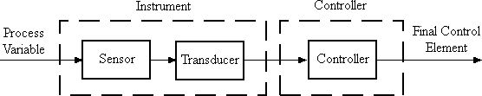

# Types of Transducers

##### Active Transducers

Active transducers convert energy directly from one form to another. They require no external power source to operate. For example, a thermocouple converts a temperature differential directly into an (resistance which can be measured by the amount of electrical voltage which it passed thru) electrical voltage.

##### Passive Transducer

Passive transducers produce a change in some passive electrical quantity, such as capacitance, resistance, or inductance, as a result of stimulation. These usually require additional electrical energy for excitation.

##### Sensors

A sensor is a transducer whose purpose is to sense (i.e. detect) some characteristic of its environs; it is used to detect a parameter in one form of energy and report it in another, often an electrical signal. For example, a pressure sensor might detect pressure (a

mechanical form of energy) and convert it to electrical signal for display at a remote gauge. Transducers are widely used in measuring instruments.

##### Actuators

An actuator is a type of motor that is responsible for moving or controlling a mechanism or system. It is operated by a source of energy, typically electric current, hydraulic fluid pressure, or pneumatic pressure, and converts that energy into motion. An actuator is the mechanism by which a control system acts upon an environment. The control system can be simple (a fixed mechanical or electronic system), software-based (e.g. a printer driver, robot control system), a human, or any other input.

##### Bidirectional

Bidirectional transducers convert physical phenomena to electrical signals and also convert electrical signals into physical phenomena. Examples of inherently bidirectional transducers are antennas, which can convert conducted electrical signals to or from propagating electromagnetic waves, and voice coils, which convert electrical signals into sound (when used in a loudspeaker) or sound into electrical signals (when used in a microphone). Likewise, DC electric motors may be used to generate electrical power if the motor shaft is turned by an external torque.

# What is S.M.A.R.T? Configuration, Signal Conditioning, Self-Diagnosis

A smart transmitter is a digital device that converts the analog information from a sensor into digital information, allowing the device to simultaneously send and receive information and transmit more than a single value.

Smart transmitters, in general, have the following common features:

* + Digital Communications
  + Configuration
  + Re-Ranging
  + Signal Conditioning
  + Self-Diagnosis

##### Digital Communications

Transmitters are capable of digital communications with both a configuration device and a process controller. Digital communications have the advantage of being free of bit errors, the ability to multiple process values and diagnostic information, and the ability to receive commands. Some smart transmitters use a shared channel for analog and digital data (Hart, Honeywell or Modbus over 4-20mA). Others use a dedicated communication bus (Profibus, Foundation Fieldbus, Device Net, and Ethernet).

##### Configuration

Smart transmitters can be configured with a handheld terminal and store the configuration settings in non-volatile memory.

##### Signal Conditioning

Smart transmitters can perform noise filtering and can provide different signal characterizations.

##### Self-Diagnosis

Smart transmitters also have self-diagnostic capability and can report malfunctions that may indicate erroneous process values.

# Measuring signal types: Digital and Analog

Both analog and digital signals find application in modern electronics, and the distinctions between these two basic forms of information is something to be covered in much greater detail later in this book. With many physical quantities, especially electrical, analog variability is easy to come by. If such a physical quantity is used as a signal medium, it will be able to represent variations of information with almost unlimited resolution.

### Digital

In the early days of industrial instrumentation, compressed air was used as a signalling medium to convey information from measuring instruments to indicating and controlling devices located remotely. The amount of air pressure corresponded to the magnitude of whatever variable was being measured. Clean, dry air at approximately 20 pounds per square inch (PSI) was supplied from an air compressor through tubing to the measuring instrument and was then regulated by that instrument according to the quantity being measured to produce a corresponding output signal. For example, a pneumatic (air signal) level "transmitter" device set up to measure height of water (the "process variable") in a storage tank would output a low air pressure when the tank was empty, a medium pressure when the tank was partially full, and a high pressure when the tank was completely full.

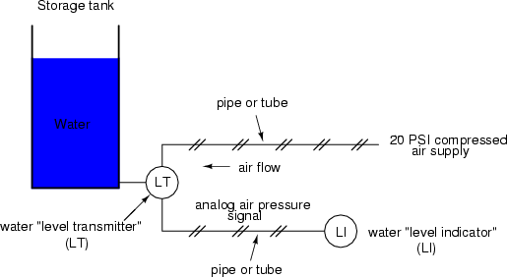

The "water level indicator" (LI) is nothing more than a pressure gauge measuring the air pressure in the pneumatic signal line. This air pressure, being a signal, is in turn a representation of the water level in the tank. Any variation of level in the tank can be represented by an appropriate variation in the pressure of the pneumatic signal. Aside from certain practical limits imposed by the mechanics of air pressure devices, this pneumatic signal is infinitely variable, able to represent any degree of change in the water's level, and is therefore analog in the truest sense of the word

Crude as it may appear, this kind of pneumatic signalling system formed the backbone of many industrial measurement and control systems around the world, and still sees use today due to its simplicity, safety, and reliability. Air pressure signals are easily transmitted through inexpensive tubes, easily measured (with mechanical pressure gauges), and are easily manipulated by mechanical devices using bellows, diaphragms, valves, and other pneumatic devices. Air pressure signals are not only useful for measuring physical processes, but for controlling them as well. With a large enough piston or diaphragm, a small air pressure signal can be used to generate a large mechanical force, which can be used to move a valve or other controlling device. Complete automatic control systems have been made using air pressure as the signal medium. They are simple, reliable, and relatively easy to understand. However, the practical limits for air pressure signal accuracy can be too limiting in some cases, especially when the compressed air is not clean and dry, and when the possibility for tubing leaks exist.

### Analog

With the advent of solid-state electronic amplifiers and other technological advances, electrical quantities of voltage and current became practical for use as analog instrument signalling media. Instead of using pneumatic pressure signals to relay information about the fullness of a water storage tank, electrical signals could relay that same information over thin wires (instead of tubing) and not require the support of such expensive equipment as air compressors to operate

Analog electronic signals are still the primary kinds of signals used in the instrumentation world today (January of 2001), but it is giving way to digital modes of communication in many applications (more on that subject later). Despite changes in technology, it is always good to have a thorough understanding of fundamental principles, so the following information will never really become obsolete.

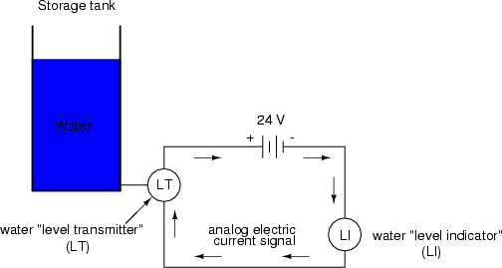

One important concept applied in many analog instrumentation signal systems is that of "live zero," a standard way of scaling a signal so that an indication of 0 percent can be discriminated from the status of a "dead" system. Take the pneumatic signal system as an example: if the signal pressure range for transmitter and indicator was designed to be 0 to 12 PSI, with 0 PSI representing 0 percent of process measurement and 12 PSI representing 100 percent, a received signal of 0 percent could be a legitimate reading of 0 percent measurement or it could mean that the system was malfunctioning (air compressor stopped, tubing broken, transmitter malfunctioning, etc.). With the 0 percent point represented by 0 PSI, there would be no easy way to distinguish one from the other.

If, however, we were to scale the instruments (transmitter and indicator) to use a scale of 3 to 15 PSI, with 3 PSI representing 0 percent and 15 PSI representing 100 percent, any kind of a malfunction resulting in zero air pressure at the indicator would generate a reading of -25 percent (0 PSI), which is clearly a faulty value. The person looking at the indicator would then be able to immediately tell that something was wrong. Not all signal standards have been set up with live zero baselines, but the more robust signals standards (3-15 PSI, 4-20 mA) have, and for good reason.

# Standard Instrumentation signals, Different current ranges

Standard systems used for signal transmission from sensor to controller in industrial processes:

|  |  |
| --- | --- |
| **Pneumatic pressure** | **3 - 15 psig, 20 - 100 kPa** |
| **Voltage** | **0 - 10 V (or 0 - 5 V)** |
| **Electric current (direct current)** | **4 - 20 mA** |

Pneumatic instrumentation in Australia and the U.S.A. has almost entirely used a 20 to 103 kpa control signal, while most European countries have used a range of 0.2 to 1.0 kg/cmz. These signals are almost identical, and this standardization has allowed equipment from different manufacturers to be used together in control loops. No such standardization has occurred in the electronic instrument field, and several manufacturers have independently adopted "standard" control signals, with the result that we now have a multitude of "standard" control signals which include 4-20 mA; 0-20 mA; 0-16 mA; 10-50 mA; 1-5 V; -10-0-10 V, and so on.

This situation, if allowed to continue without some real standardization, will eventually prove to be very expensive. Within the instrumentation industry there has been some attempt to standardize on a 20-103 kPa signal, and most manufacturers are producing equipment that will use this signal. However, it has been realized that there are several major disadvantages with any signal that has an elevated zero, and several major instrument companies are now producing equipment with control signals based on zero. This move to a zero-based control signal has only just started to gain momentum throughout the world, but it should be seriously considered by mills about to embark on an electronic instrumentation project.

To illustrate the two basic types of control signals available, consider three types of level transmitter to be used to indicate the level in a tank.

* + A conventional pneumatic transmitter output 20-103 kPa
  + A live based signal output 4-20 mA
  + A zero-based signal output 0-20 mA.

### The Live Zero-Based Control Signal

The live-base control signal has following advantages:

* + Allows the use of a two-wire control system and
  + Will indicate a catastrophic failure of a control loop if the zero is being monitored. Its big disadvantage is that extra equipment is necessary to depress the zero in order to carry out simple arithmetic manipulation (i.e., summing, square root extraction, multiplication and division) and analog to digital conversion. Instrument companies using live-based signals sy2tems sometimes deny this but it is invariably carried out within their equipment. This increases the cost and must reduce the accuracy of any piece of equipment. The use of the two- wire system has the advantage that it saves two wires between the transmitter and receiver. This can be considered a saving only in the initial cost of cable in an installation. It has some inherent disadvantages in complex installations. Where a common power supply is used to drive two or more transmitters, the outputs are usually not isolated from each other .This can cause serious problems and may necessitate the use of separate power supplies and/or other isolating devices. These can significantly add to the cost of the installation.

# Instrument properties effect on process

You can improve accuracy by knowing how errors occur and how to correct for them. This topic discusses the sources of measurement error and how to monitor error terms.

* + Drift Errors
  + Random Errors
  + Systematic Errors
  + 3-Port Error Terms
  + 4-Port Error Terms
  + Monitoring Error Terms

##### Drift Errors

Drift errors are due to the instrument or test-system performance changing after a calibration has been done. Drift errors are primarily caused by thermal expansion characteristics of interconnecting cables within the test set and conversion stability of the microwave frequency converter and can be removed by re-calibrating. The time frame over which a calibration remains accurate is dependent on the rate of drift that the test system undergoes in your test environment. Providing a stable ambient temperature usually minimizes drift. For more information, see Measurement Stability.

##### Random Errors

Random errors are not predictable and cannot be removed through error correction. However, there are things that can be done to minimize their impact on measurement accuracy. The following explains the three main sources of random errors.

##### Switch Repeatability Errors

Mechanical RF switches are used in the analyser to switch the source attenuator settings. Sometimes when mechanical RF switches are activated; the contacts close differently from when they were previously activated. When this occurs, it can adversely affect the accuracy of a measurement. You can reduce the effects of switch repeatability errors by avoiding switching attenuator settings during a critical measurement.

##### Connector Repeatability Errors

Connector wear causes changes in electrical performance. You can reduce connector repeatability errors by practicing good connector care methods. See Connector Care.

##### Systematic Errors

Systematic errors are caused by imperfections in the analysers and test setup. They are repeatable (and therefore predictable), and are assumed to be time invariant. They can be characterized during the calibration process and mathematically reduced during measurements. They are never completely removed. There are always some residual errors due to limitations in the calibration process. The residual (after measurement calibration) systematic errors result from:

* + Imperfections in the calibration standards
  + Connector interface
  + Interconnecting cables
  + Instrumentation

# Instrument noise

Noise is unwanted electrical disturbances generated in the components of the analyser. These disturbances include:

* + Low level noise due to the broadband noise floor of the receiver.
  + High level noise or jitter of the trace data due to the noise floor and the phase noise of the LO source inside the test set.
  + You can reduce noise errors by doing one or more of the following:
  + Increase the source power to the device being measured - ONLY reduces low-level noise.
  + Narrow the IF bandwidth.
  + Apply several measurement sweep averages.

# Pressure measurements What is Pressure?

Pressure (symbol: p or P) is the force applied perpendicular to the surface of an object per unit

area over which that force is distributed. Gauge pressure (also spelled gage pressure) is the pressure relative to the ambient pressure. Various units are used to express pressure. Some of these derive from a unit of force divided by a unit of area; the SI unit of pressure, the Pascal (Pa), for example, is one Newton per square metre; similarly, the pound-force per square inch (psi) is the traditional unit of pressure in the imperial and US customary systems.

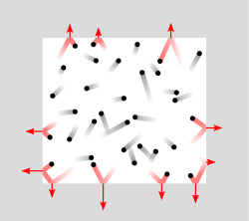

##### Pressure:

*Pressure is the amount of force acting per unit area.*

The symbol for pressure is *p* or *P*. The IUPAC recommendation for pressure is a lower-case *p*. However, upper-case *P* is widely used. The usage of *P* vs. *p* depends on the field in which one is working, on the nearby presence of other symbols for quantities such as power and momentum, and on writing style. Pressure may also be expressed in terms of standard atmospheric pressure; the atmosphere (atm) is equal to this pressure and the torr is defined as 1⁄760 of this. Mano metric units such as the centimetre of water, millimetre of mercury and inch of mercury are used to express pressures in terms of the height of column of a particular fluid in a manometer.

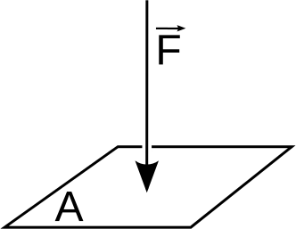

##### Formula:

Mathematically:



*Where*:

p Is the pressure

F Is the normal force

A Is the area of the surface on contact

Pressure is a scalar quantity. It relates the vector surface element (a vector normal to the surface) with the normal force acting on it. The pressure is the scalar proportionality constant that relates the two normal vectors:



The minus sign comes from the fact that the force is considered towards the surface element, while the normal vector points outward. The equation has meaning in that, for any surface S in contact with the fluid, the total force exerted by the fluid on that surface is the surface integral over S of the right-hand side of the above equation.

It is incorrect (although rather usual) to say "the pressure is directed in such or such direction". The pressure, as a scalar, has no direction. The force given by the previous relationship to the quantity has a direction, but the pressure does not. If we change the orientation of the surface element, the direction of the normal force changes accordingly, but the pressure remains the same. Pressure is transmitted to solid boundaries or across arbitrary sections of fluid *normal to* these boundaries or sections at every point. It is a fundamental parameter in thermodynamics, and it is conjugate to volume.

# Units for pressure measurements

##### Atmosphere (atm)

* **Manometric units:**
  + Centimetre, inch, and millimetre of mercury (torr)
  + Height of equivalent column of water, including millimetre (mm h2o), centimetre (cm h2o), metre, inch, and foot of water

##### Imperial and customary units:

* + Kip, short ton-force, long ton-force, pound-force, ounce-force, and poundal per square inch
  + Short ton-force and long ton-force per square inch
  + Fsw (feet sea water) used in underwater diving, particularly in connection with diving pressure exposure and decompression

##### Non-SI metric units:

* + Bar, decibar, millibar
  + Msw (metres sea water), used in underwater diving, particularly in connection with diving pressure exposure and decompression
  + Kilogram-force, or kilopond, per square centimetre (technical atmosphere)
  + Gram-force and tonne-force (metric ton-force) per square centimetre
  + Barye (dyne per square centimetre)
  + Kilogram-force and tonne-force per square metre
  + Sthene per square metre (pieze)

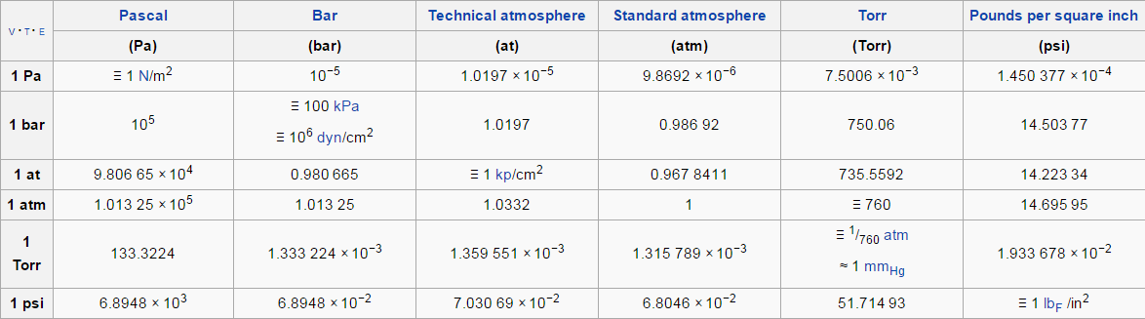

# Types of Pressure measurements

Many techniques have been developed for the measurement of pressure and vacuum. Instruments used to measure pressure are called pressure gauges or vacuum gauges.

### Gauge (G)

Measures the input pressure (of your media) with reference to ambient atmospheric pressure (vented to atmosphere). Gauge is used to measure pressure relative to ambient conditions, such as with car tyre pressure. As the sensors are open to the atmosphere, they are susceptible to humidity. Care must be taken that units are installed in dry areas (otherwise internal circuitry can fail).

### Sealed (S)

Measures the input pressure (of your media) with reference to a sealed chamber closed with atmospheric pressure (approximately 1bar). This protects the internal circuitry of the sensor from humidity. This range is normally restricted to minimum 7bar and above. Outside installations or where the equipment may be washed are good application examples.

### Absolute (A)

Measures the input pressure (of your media) with reference to a vacuum chamber at 0bar (evacuated and hermetically sealed). Specified where absolute pressure measurements are required, e.g. barometric pressures, or where equipment needs to have all the air removed.

### Differential (D)

Here the reference pressure is neither ambient nor internal to the sensor. The sensor is supplied with two ports – high and low inputs – and will measure the difference between the two. Generally used for filter measurement applications.

|  |  |  |
| --- | --- | --- |
| **Absolute Pressure** | **Gauge Pressure** | **Differential Pressure** |

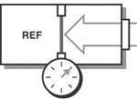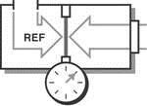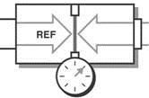

# Bourdon tube

### Principle

*When an elastic transducer (bourdon tube in this case) is subjected to a pressure, it defects. This deflection is proportional to the applied pressure when calibrated.*

Bourdon Tubes are known for its very high range of differential pressure measurement in the range of almost 100,000 psi (700 MPa). It is an elastic type pressure transducer. The device was invented by Eugene Bourdon in the year 1849. The basic idea behind the device is that, cross-sectional tubing when deformed in any way will tend to regain its circular form under the action of pressure. The bourdon pressure gauges used today have a slight elliptical cross- section and the tube is generally bent into a C-shape or arc length of about 27 degrees. The detailed diagram of the bourdon tube is shown below.

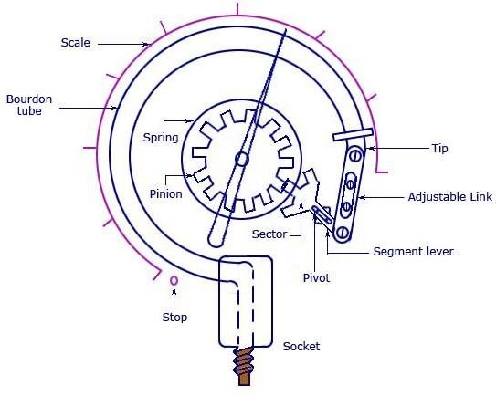

As seen in the figure, the pressure input is given to a socket which is soldered to the tube at the base. The other end or free end of the device is sealed by a tip. This tip is connected to a segmental lever through an adjustable length link. The lever length may also be adjustable. The segmental lever is suitably pivoted and the spindle holds the pointer as shown in the figure. A hair spring is sometimes used to fasten the spindle of the frame of the instrument to provide

necessary tension for proper meshing of the gear teeth and thereby freeing the system from the backlash. Any error due to friction in the spindle bearings is known as lost motion. The mechanical construction has to be highly accurate in the case of a Bourdon Tube Gauge. If we consider a cross-section of the tube, its outer edge will have a larger surface than the inner portion. The tube walls will have a thickness between 0.01 and 0.05 inches.

### Working

As the fluid pressure enters the bourdon tube, it tries to be reformed and because of a free tip available, this action causes the tip to travel in free space and the tube unwinds. The simultaneous actions of bending and tension due to the internal pressure make a non-linear movement of the free tip. This travel is suitable guided and amplified for the measurement of the internal pressure. But the main requirement of the device is that whenever the same pressure is applied, the movement of the tip should be the same and on withdrawal of the pressure the tip should return to the initial point.

A lot of compound stresses originate in the tube as soon as the pressure is applied. This makes the travel of the tip to be non-linear in nature. If the tip travel is considerably small, the stresses can be considered to produce a linear motion that is parallel to the axis of the link. The small linear tip movement is matched with a rotational pointer movement. This is known as multiplication, which can be adjusted by adjusting the length of the lever. For the same amount of tip travel, a shorter lever gives larger rotation. The approximately linear motion of the tip when converted to a circular motion with the link-lever and pinion attachment, a one-to-one correspondence between them may not occur and distortion results. This is known as angularity which can be minimized by adjusting the length of the link.

Other than C-type, bourdon gauges can also be constructed in the form of a helix or a spiral. The types are varied for specific uses and space accommodations, for better linearity and larger sensitivity. For thorough repeatability, the bourdon tubes materials must have good elastic or spring characteristics. The surrounding in which the process is carried out is also important as corrosive atmosphere or fluid would require a material which is corrosion proof. The commonly used materials are phosphor-bronze, silicon-bronze, beryllium-copper, Inconel, and other C-Cr-Ni-Mo alloys, and so on.

In the case of forming processes, empirical relations are known to choose the tube size, shape and thickness and the radius of the C-tube. Because of the internal pressure, the near elliptic or rather the flattened section of the tube tries to expand as shown by the dotted line in the figure below (a). The same expansion lengthwise is shown in figure (b). The arrangement of the tube, however forces an expansion on the outer surface and a compression on the inner surface, thus allowing the tube to unwind. This is shown in figure (c).

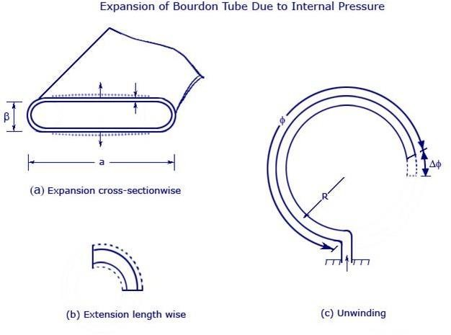

Expansion of Bourdon Tube Due to Internal Pressure

Like all elastic elements a bourdon tube also has some hysteresis in a given pressure cycle. By proper choice of material and its heat treatment, this may be kept to within 0.1 and 0.5 percent of the maximum pressure cycle. Sensitivity of the tip movement of a bourdon element without restraint can be as high as 0.01 percent of full range pressure reducing to 0.1 percent with restraint at the central pivot.

### Advantages

* + Can be used for a wide range or pressures, from 0 to 7000 atm
  + Can be used instead of manometers at extreme pressures and temperatures

### Disadvantages

* + Measurement of pressure at high temperatures may cause deformation in the gauge, resulting in systematic errors

### Usage example

The bourdon gauge is the most common pressure equipment because it allows for a wide range of pressure measurements. Notice the many uses of the bourdon gauge on these processes.

##### Types of Bourdon tube

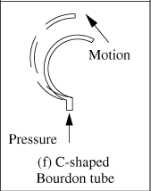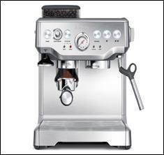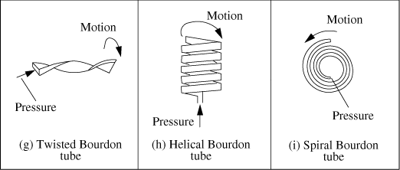

# Diaphragm

A second type of aneroid gauge uses deflection of a flexible membrane that separates regions of different pressure. The amount of deflection is repeatable for known pressures so the pressure can be determined by using calibration. The deformation of a thin diaphragm is dependent on the difference in pressure between its two faces. The reference face can be open to atmosphere to measure gauge pressure, open to a second port to measure differential pressure, or can be sealed against a vacuum or other fixed reference pressure to measure absolute pressure. The

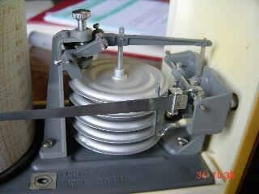

deformation can be measured using mechanical, optical or capacitive techniques. Ceramic and metallic diaphragms are used.

##### Useful range: above 10−2 torr (roughly 1 Pa)

For absolute measurements, welded pressure capsules with diaphragms on either side are often used.

##### Shape

* + Flat
  + corrugated
  + flattened tube
  + capsule

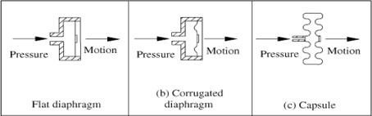

# Manometer

The height of the liquid in a manometer is directly proportional to the hydrostatic pressure. The picture below shows an inclined manometer.

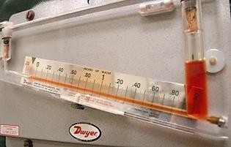

The three major types of manometers are: differential, sealed-end, and open-end.

##### Differential manometer

A differential manometer is different than a sealed-end or an open-end manometer in that the two ends are exposed to different points along the flow path. The difference in fluid heights yields the pressure difference between the two points. The small difference in liquid heights is more easily measured along the angled line ("L") than along the vertical stem ("h").

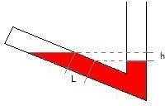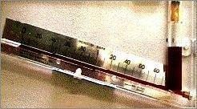

##### Sealed-end Manometer

In sealed-end manometers the open end is open to the fluid of interest, while the closed end encloses a vacuum. For example, in a barometer, atmospheric pressure, Patm, pushes some of the mercury from the reservoir into and up the glass tube. The height of the liquid column, h, then represents the atmospheric pressure.

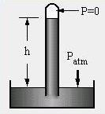

##### Open-end Manometer

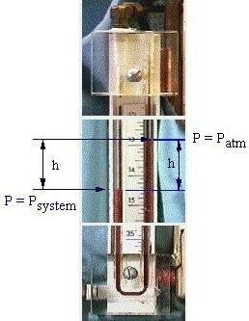

In open-end manometers one arm is exposed to the fluid being monitored, and the other arm is open to the atmosphere. The picture below shows an open- end manometer from a unit operations laboratory. It is actually over six feet tall, so only some parts are shown here.

In this example, the system pressure is greater than atmospheric pressure. The gas in the left arm then pushes some of the liquid in the manometer into the other arm. The resulting height difference h represents the pressure difference between the system and the atmosphere.

**Usage examples**

On the left the hydrostatic head or static head of water manometer is used to measure the pressure between the surface water and groundwater. Manometers are also useful in the medical field. For example, the sphygmomanometer to the right is used to measure blood pressure.

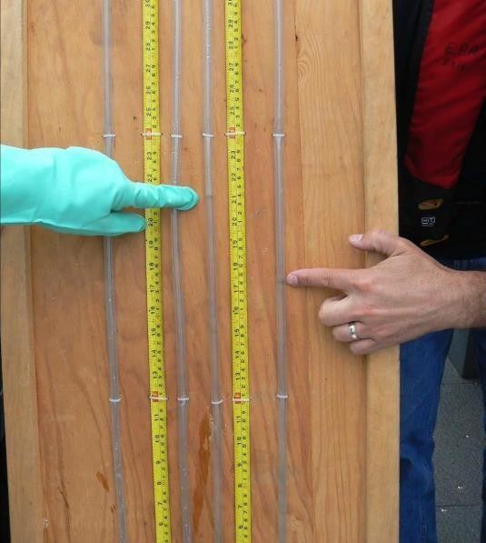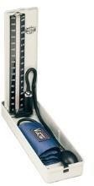

### Advantages

* + Easy to read, height difference is proportional to pressure
  + No moving parts

### Disadvantages

* + Cannot measure high pressures with great accuracy
  + Small pressure range
  + Contain fluids which can be dangerous when exposed to high temperatures, limiting manometers to low temperature systems

# Piezo resistive

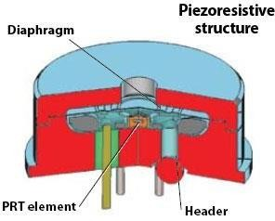

The sensing material in a piezo resistive pressure sensor is a diaphragm formed on a silicon substrate, which bends with applied pressure. A deformation occurs in the crystal lattice of the diaphragm because of that bending. This deformation causes a change in the band structure of the piezo resistors that are placed on the diaphragm, leading to a change in the resistivity of the material. This change can be an increase or a decrease according to the orientation of the resistors. In this project, our aim is to produce low-cost piezo resistive pressure sensors with various sensitivities for industrial applications. This variation in the sensitivity of the sensor will enlarge the application areas of the sensors. Those sensors will also include temperature sensors. With those, temperature information can be obtained and can be used for temperature compensation purposes.

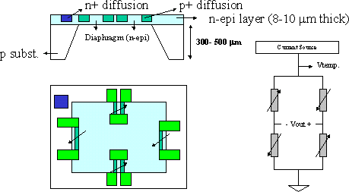

### Application area

* + Household Appliances: Washing machines, dishwashers, vacuum cleaners;
  + Automotive Applications: Oil level, gas level, air pressure detection;
  + Biomedical Applications: Blood pressure measurement, etc...

### Advantages

* + Low-cost sensor fabrication opportunity.
  + Mature processing technology.
  + Different pressure levels can be achieved according to the application.
  + Also, various sensitivities can be obtained.
  + Read-out circuitry can be either on-chip or discrete.

# Capacitance

Capacitors are composed of two parallel conducting plates, carrying the same and opposite charge. In a capacitance diaphragm gauge, one or both plates are diaphragms. When pressurized, the diaphragm deflects and changes the dielectric thickness, as shown below on the right.

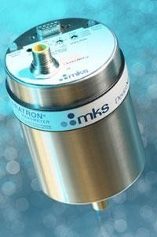

Capacitance diaphragm gauges with two diaphragms as their pressure sensor can be used to measure differential pressure, in applications with two pressure sources. The diagram below depicts a capacitance manometer that acts as a stand-alone transducer. It measures the pressure by sending a signal from 0-10 volts that is directly proportional to the pressure.

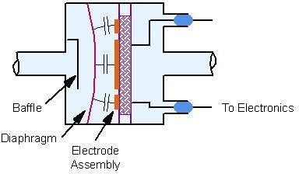

##### Usage examples

The picture below shows four capacitance manometers that were used to monitor the outlet gas pressures from four district regulators.

# Strain Gauge

There are two types of strain gauges: unbounded and bonded. The unbounded strain gauge on the left consists of two wires connected to a fixed frame and two wires connected to a movable armature. When pressure is applied to the diaphragm, the armature moves, and two wires stretch while the other two contract. The resulting change in electrical resistance reflects the pressure applied.

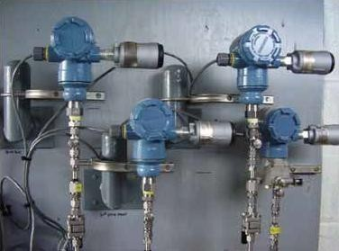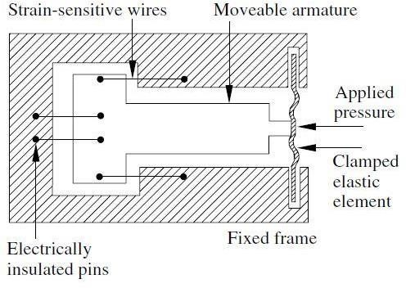

In bonded strain gauges, on the other hand, the wire filament is embedded in cloth, paper, plastic, or resin and is mounted onto a flexible plate, as shown above. When pressure is applied to the flexible plate, the filament wires stretch or contract. The resulting change in resistance reflects the pressure applied.

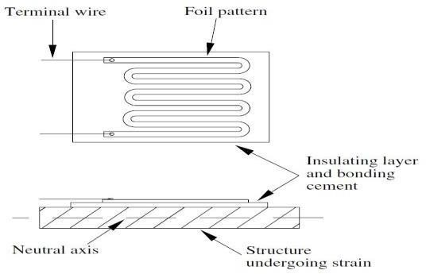

### Usage examples

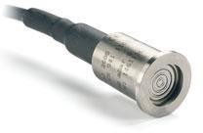

Micro-machined silicon pressure sensors with strain gauges can be used in precision pressure transmitters such as the one below. The gauges are isolated from the pressure source by an external diaphragm. Pressure is transmitted through silicon oil located between the diaphragm and the sensor.

# Vibrating Wire

Vibrating element pressure sensors function by measuring a change in resonant frequency of a vibrating element. A current is passed through a wire which induces an electromotive force within the wire. The force is then amplified and causes oscillation of the wire. Pressure affects this mechanism by affecting the wire itself: an increase in pressure decreases the tension within the wire and thus lowers the angular

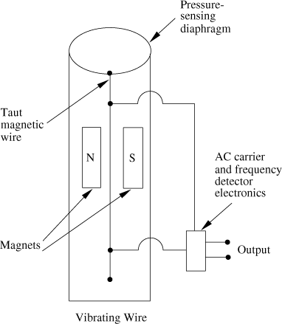

frequency of oscillation of the wire. The sensor is housed in a cylinder under vacuum when measuring absolute pressures. These absolute pressure measuring sensors are very efficient: they produce repeatable results and are not affected by temperature greatly. They lack sensitivity in measurement, though, so they would not be ideal for a process in which minute pressures need monitoring. The pressure range is 0.0035 - 0.3 MPa with a sensitivity of 1E-5 MPa.

A vibrating wire pressure sensor is shown above. A vibrating cylinder pressure sensor (for absolute pressures) is shown below.

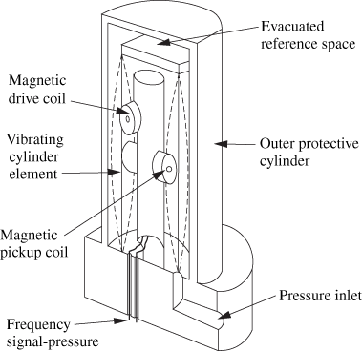

# Linear Variable Differential Transformer (LVDT)

Linear Variable Differential Transformers (LVDTs) consist of a magnetic core, an elastic element such as a diaphragm, and one primary and two secondary coils. Voltage is applied to the primary coil to produce a magnetic field. When the core is centred, the induced voltages in the secondary coils are equal and opposite.

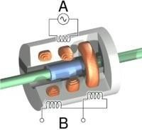

When pressure is applied to the system, the diaphragm moves, shifting the magnetic core and inducing a voltage in one secondary coil and decreasing the voltage in the other. This voltage difference is linearly proportional to pressure and can be measured accordingly.

### Operation

The linear variable differential transformer has three solenoid coils placed end-to-end around a tube. The center coil is the primary, and the two outer coils are the top and bottom secondary. A cylindrical ferromagnetic core, attached to the object whose position is to be measured, slides along the axis of the tube. An alternating current drives the primary and causes a voltage to be induced in each secondary proportional to the length of the core linking to the secondary. The frequency is usually in the range 1 to 10 kHz.

As the core moves, the primary's linkage to the two secondary coils changes and causes the induced voltages to change. The coils are connected so that the output voltage is the difference (hence "differential") between the top secondary voltage and the bottom secondary voltage. When the core is in its central position, equidistant between the two secondary’s, equal voltages are induced in the two secondary coils, but the two signals cancel, so the output voltage is theoretically zero. In practice minor variations in the way in which the primary is coupled to each secondary means that a small voltage is output when the core is central.

When the core is displaced toward the top, the voltage in the top secondary coil increases as the voltage in the bottom decreases. The resulting output voltage increases from zero. This voltage is in phase with the primary voltage. When the core moves in the other direction, the output voltage also increases from zero, but its phase is opposite to that of the primary. The phase of the output voltage determines the direction of the displacement (up or down) and amplitude indicates the amount of displacement. A synchronous detector can determine a signed output voltage that relates to the displacement.

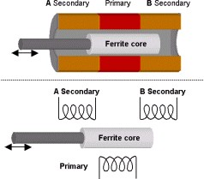

The LVDT is designed with long slender coils

to make the output voltage essentially linear over displacement up to several inches (several hundred millimeters) long. The LVDT can be used as an absolute position sensor. Even if the power is switched off, on restarting it, the LVDT shows the same measurement, and no positional information is lost. Its biggest advantages are repeatability and reproducibility once it is properly configured. Also, apart from the uni-axial linear motion of the core, any other movements such as the rotation of the core around the axis will not affect its measurements.

Because the sliding core does not touch the inside of the tube, it can move without friction, making the LVDT a highly reliable device. The absence of any sliding or rotating contacts allows the LVDT to be completely sealed against the environment. LVDTs are commonly used for position feedback in servomechanisms, and for automated measurement in machine tools and many other industrial and scientific applications.

# Optical

Optical type pressure measurement is receiving considerable attention in recent years where the movement of a diaphragm, a bellows element or such other primary sensors are detected by optical means. The principle is nothing new, but the technique of adaptation in commercialization is varied in nature. A typical case with a diaphragm and a vane attached to it that covers and uncovers an irradiated photo diode with changing pressure is shown in the figure below.

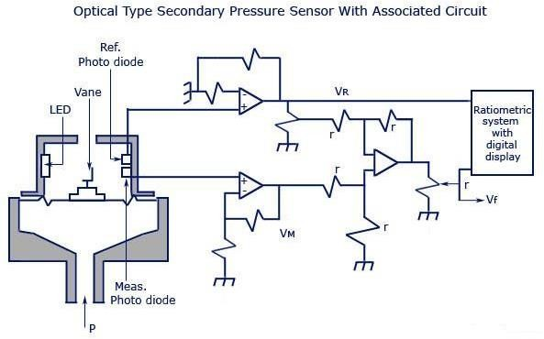

The circuit diagram shows that if any instant uncovering area of the photo diode is Am, and that of reference one is Ar, with other notations shown in the figure, the ratio metric output would be

##### Vf/VR = G (Am/Ar – a)

G – Span adjusted

a – Zero adjustment co-efficient

Calibration may be made directly in pressure. The ratio metric technique is often preferred for avoiding drift error in electronic components as they are likely to be equally affected and cancelled. The vane movement or the diaphragm movement is kept small for negligible hysteresis and good precision. Diode signals have non-linearity which may also vary from unit to unit. The non-linearity are often linearized using look up table in programmable read only memories during A/D conversion process. The range may be adjusted from (0-400)MPa with an accuracy of 0.1 percent scan. Temperature, though compensated, affects measurement to a certain extent which, in zero scale may be compensated by auto-zeroing facility

# Temperature measurement

# What is Temperature: Units for temperature measurements

Temperature is an objective comparative measure of hot or cold. It is measured by a thermometer, which may work through the bulk behaviour of a thermometric material, detection of thermal radiation, or particle kinetic energy. Several scales and units exist for measuring temperature, the most common being Celsius (denoted °C; formerly called centigrade), Fahrenheit (denoted °F), and, especially in science, Kelvin (denoted K).

The coldest theoretical temperature is absolute zero, at which the thermal motion of atoms and molecules reaches its minimum - classically, this would be a state of motionlessness, but quantum uncertainty dictates that the particles still possess a finite zero-point energy. In addition to this, a real system or object can never be brought to a temperature of absolute zero by thermodynamic means. Absolute zero is denoted as 0 K on the Kelvin scale, −273.15 °C on the Celsius scale, and −459.67 °F on the Fahrenheit scale. For an ideal gas, temperature is proportional to the average kinetic energy of the random microscopic motions of the constituent microscopic particles.

|  |  |  |
| --- | --- | --- |
|  | **from Celsius** | **to Celsius** |
| **Fahrenheit** | [°F] = [°C] × 9⁄5 + 32 | [°C] = ([°F] − 32) × 5⁄9 |
| **Kelvin** | [K] = [°C] + 273.15 | [°C] = [K] − 273.15 |
| **Rankine** | [°R] = ([°C] + 273.15) × 9⁄5 | [°C] = ([°R] − 491.67) × 5⁄9 |
| **Delisle** | [°De] = (100 − [°C]) × 3⁄2 | [°C] = 100 − [°De] × 2⁄3 |
| **Newton** | [°N] = [°C] × 33⁄100 | [°C] = [°N] × 100⁄33 |
| **Réaumur** | [°Ré] = [°C] × 4⁄5 | [°C] = [°Ré] × 5⁄4 |
| **Rømer** | [°Rø] = [°C] × 21⁄40 + 7.5 | [°C] = ([°Rø] − 7.5) × 40⁄21 |

# Resistance Temperature Detectors (RTD)

A second commonly used temperature sensor is the resistance temperature detector (RTD, also known as resistance thermometer). Unlike filled system thermometers, the RTD provides an electrical means of temperature measurement, thus making it more convenient for use with a computerized system. An RTD utilizes the relationship between electrical resistance and temperature, which may either be linear or nonlinear. RTDs are traditionally used for their high accuracy and precision. However, at high temperatures (above 700°C) they become very inaccurate due to degradation of the outer sheath, which contains the thermometer. Therefore, RTD usage is preferred at lower temperature ranges, where they are the most accurate.

There are two main types of RTDs, the traditional RTD and the thermistor. Traditional RTDs use metallic sensing elements that result in a linear relationship between temperature and resistance. As the temperature of the metal increases, increased random molecular movement impedes the flow of electrons. The increased resistance is measured as a reduced current through the metal for a fixed voltage applied. The thermistor uses a semiconductor sensor, which gives a power function relationship between temperature and resistance.

### RTD Structure

A schematic diagram of a typical RTD is shown in Figure As shown in Figure, the RTD contains an

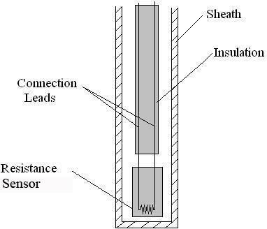

outer sheath to prevent contamination from

the surrounding medium. Ideally, this sheath is composed of material that efficiently conducts heat to the resistor, but resists degradation from heat or the surrounding medium.

The resistance sensor itself is responsible for the temperature measurement, as shown in the diagram. Sensors are most commonly composed of metals, such as platinum, nickel, or copper. The material chosen for the sensor determines the range of temperatures in which the RTD could be used. For example, platinum sensors, the most common type of resistor, have a range of approximately -200°C – 800°C. (A sample of the temperature ranges and resistances for the most common resistor metals is shown in Table). Connected to the sensor are two insulated connection leads. These leads continue to complete the resistor circuit.

### Common Metal Temperature and Resistance Ranges

|  |  |  |  |
| --- | --- | --- | --- |
| **Element Metal** | **Temperature Range** | **Base Resistance** | **TCR(Ω/Ω/°C)** |
| **Copper** | -100 – 260 °C | 10 Ω at 0 °C | 0.00427 |
| **Nickel** | -100 – 260 °C | 120 Ω at 0 °C | 0.00672 |
| **Platinum** | -260 – 800 °C | 100 Ω at 0 °C | 0.003916 |

There are 4 major categories of RTD sensors. There are carbon resistors, film thermometers, wire-wound thermometers and coil elements. Carbon resisters are the most commonly used. They are inexpensive and are accurate for low temperatures. They also are not affected by hysteresis or strain gauge effects. They are commonly used by researchers.

Film thermometers have a very thin layer of metal, often platinum, on a plate. This layer is very small, on the micrometre scale. These thermometers have different strain gauge effects based on what the metal and plates are composed of. There are also stability problems that are dependent on the components used. In wire-wound thermometers the coil gives stability to the measurement. A larger diameter of the coil adds stability, but it also increases the amount the wire can expand which increases strain and drift. They have very good accuracy over a large temperature range.

Coil elements are similar to wire-wound thermometers and have generally replaced them in all industrial applications. The coil is allowed to expand over large temperature ranges while still giving support. This allows for a large temperature range while decreasing the drift.

RTD Operation

Most traditional RTD operation is based upon a linear relationship between resistance and temperature, where the resistance increases with temperature. For this reason, most RTDs are made of platinum, which is linear over a greater range of temperatures and is resistant to corrosion. However, when determining a resistor material, factors such as temperature range, temperature sensitivity, response time, and durability should all be taken into consideration. Different materials have different ranges for each of these characteristics.

The principle behind RTDs is based upon the **Callendar – Van Dusen** equation shown below, which relates the electrical resistance to the temperature in °C. This equation is merely a generic polynomial that takes form based upon experimental data from the specific RTD. This equation usually takes on a linear form since the coefficients of the higher-order variables (a2, a3, etc.) are relatively small.

**RT=R0 (1 + A1T + A 2 + A 3 +** **A 4 +...+ A n) \qquad (**1)

**2T 3T 4T nT**

*Where,*

RT: Resistance at temperature T, in ohms R0: Resistance at temperature = 0°C, in ohms An: Material’s resistance constant, in °Cn − 1

Another type of RTD is the thermistor, which operates based upon an exponential relationship between electrical resistance and temperature. Thermistors are primarily composed of semiconductors, and are usually used as fuses, or current-limiting devices. Thermistors have high thermal sensitivity but low temperature measuring ranges and are extremely non-linear.

Errors associated with resistance thermometers will occur due to the individual or collective efforts of: defective insulation, contamination of the resistor, or insecure lead wire connections.

# Thermocouples

Another temperature sensor often used in industry is the thermocouple. Among the various temperature sensors available, the thermocouple is the most widely used sensor. Similar to the RTD, the thermocouple provides an electrical measurement of temperature.

### Thermocouple Structure

The thermocouple has a long, slender, rod-like shape, which allows it to be conveniently placed in small, tight places that would otherwise be difficult to reach. A schematic diagram of a typical thermocouple is shown in Figure.

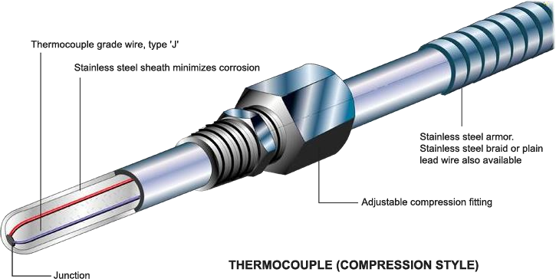

As illustrated in Figure, the thermocouple contains an outer sheath, or thermo well. The thermo well protects the contents of the thermocouple from mechanical and chemical damage.

Within the thermo well lies two metal wires each consisting of different metals. Various combinations of materials are possible for these metal wires. Three common thermocouple material combinations used for moderate temperature measurements are the Platinum-

Rhodium, Iron-Constantan, and Chromel- Alumel metal alloys. The metal alloys chosen for a thermocouple is based upon the EMF value of the alloy pair at a given temperature. Sample EMF values for the most common materials at various temperatures are shown in Table. For a given pair of materials, the two wires are connected at one end to form a junction. At the other end, the two wires are connected to a voltage measuring device. These ends of the wires are held at a different reference temperature.

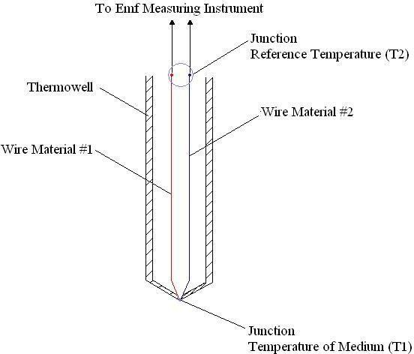

### Common Metal Temperature and EMF Values

|  |  |  |  |
| --- | --- | --- | --- |
| **Alloy Type** | **EMF Value at 20 °C** | **EMF Value at 50 °C** | **EMF Value at 100**  **°C** |
| **Platinum-Rhodium** | 0.113 mV | 0.299 mV | 0.646 mV |
| **Iron-Constantan** | 1.019 mV | 2.585 mV | 5.269 mV |
| **Chromel-Alumel** | 0.798 mV | 2.023 mV | 4.096 mV |

Various methods are used to maintain the reference temperature at a known, constant temperature. One method consists of placement of the reference junction within either an ice bath or oven maintained at a constant temperature. More commonly, the reference temperature is maintained electronically. Though not as stable as an ice bath, electronically controlled reference temperatures are more convenient for use. Reference temperatures could also be maintained through temperature compensation and zone boxes, which are regions of uniform temperature. The voltage difference across the reference junction is measured and sent to a computer, which then calculates the temperature with this data.

Thermocouple Operation

The main principle upon which the thermocouple function is based on is the difference in the conductivities of the two wire materials that the thermocouple is made of, at a given temperature. This conductivity difference increases at higher temperatures and conversely, the conductivity difference decreases at lower temperatures. This disparity results in the thermocouples being more efficient and useful at higher temperatures. Since the conductivity difference is small at lower temperatures and thus more difficult to detect, they are inefficient and highly unreliable at low temperatures.

The conductivity difference between the two wires, along with a temperature difference between the two junctions, creates an electrical current that flows through the thermocouple. The first junction point, which is the point at which the two wires are connected, is placed within the medium whose temperature is being measured. The second junction point is constantly held at a known reference temperature. When the temperature of the medium differs from the reference temperature, a current flows through the circuit. The strength of this current is based upon the temperature of the medium, the reference temperature, and the materials of the metal wires. Since the reference temperature and materials are known, the temperature of the medium can be determined from the current strength.

Error associated with the thermocouple occurs at lower temperatures due to the difficulty in detecting a difference in conductivities. Therefore, thermocouples are more commonly used at higher temperatures (above -125°C) because it is easier to detect differences in conductivities. Thermocouples are operable over a wide range of temperatures, from -200°C to 2320°C, which indicates its robustness and vast applications. Thermocouples operate over this wide range of temperatures, without needing a battery as a power source. It should be noted that, the wire insulation might wear out over time by heavy use, thus requiring periodical checks and maintenance to preserve the accuracy of the thermocouple.

To determine the temperature of the medium from the current strength, the EMF or voltage values of the current and of the wire materials at the reference temperatures must be known. Often, the measured temperature can be found by using standard thermocouple tables. However, these tables are often referenced at 0°C. To correct for this different reference temperature, equation (3) can be used to calculate the temperature from a given current.

**E {T1,T3} = E {T1, T2} + E {T2, T3}** (2)

*Where*,

E: EMF of an alloy combination generated at two different temperatures T1: temperature of the medium whose temperature is to be determined T2: reference temperature of the thermocouple

T3: reference temperature of the standard thermocouple table, which in this case is 0°C

Once the EMF between two alloys is calculated relative to a reference temperature when T3 is 0°C, the standard thermocouple table can be used to determine the temperature T1 of the medium. This temperature is usually automatically displayed on the thermocouple.

Apart from the common occurrence of the thermocouples being placed in the fluid to measure temperature change, thermocouples can be also embedded in solids with excellent results. This is highly effective while establishing the different thermal properties for a solid. The heat transfer to the thermocouple will now be in the form of conductive heat transfer. As a result, this setup would be very similar to heat conduction in series, since the thermocouple is almost always made from a different material then the actual solid. Such discrepancies depend on the

manner in which the thermocouple is embedded in the solid and should be taken into account when the thermal properties are being calculated and analysed. One example is shown in the photo below.

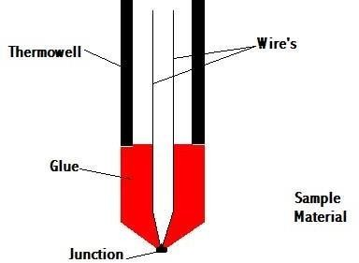

### Laws for thermocouples

###### Law of homogenous material

If all the wires and the thermocouple are made of the same material, temperature changes in the wiring do not affect the output voltage. Thus, need different materials to adequately reflect the temperature.

###### Law of intermediate materials

The sum of all the thermoelectric forces in a circuit with a number of dissimilar materials at a uniform temperature is zero. This implies that if a third material is added at the same temperature, no net voltage is generated by the new material.

###### Law of successive or intermediate temperatures

If two dissimilar homogeneous materials produce thermal emf1 when the junctions are at T1 and T2 and produce thermal emf2 when the junctions are at T2 and T3, the emf generated when the junctions are at T1 and T3 will be emf1 + emf2.

### Application

###### Steel industry

Monitor temperature and chemistry throughout the steel making process

###### Heating appliance safety

Thermocouples in fail-safe mode are used in ovens and water heaters to detect if pilot flame is burning to prevent fire and health hazard

###### Manufacturing

Used for testing prototype electrical and mechanical apparatus

###### Process plants

Chemical production plants and refineries use computer programs to view the temperature at various locations. For this situation, a number of thermocouple leads are brought to a common reference block.

# Thermistor

A thermistor is a type of resistor whose resistance is dependent on temperature, more so than in standard resistors. The word is a portmanteau of thermal and resistor.

Thermistors differ from resistance temperature detectors (RTDs) in that the material used in a thermistor is generally a ceramic or polymer, while RTDs use pure metals. The temperature response is also different; RTDs are useful over larger temperature ranges, while thermistors typically achieve a greater precision within a limited temperature range, typically −90 °C to 130 °C.

##### There are two types of thermistor.

* **Positive temperature coefficient**

(PTC) refers to materials that experience an increase in electrical resistance when their temperature is raised. Materials which have useful engineering applications usually show a relatively rapid increase with temperature, i.e. a higher coefficient. The higher the coefficient, the greater an increase in electrical resistance for a given temperature increase. T ↑ R ↑ I ↓

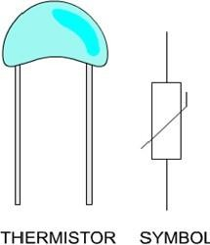

##### Negative temperature coefficient

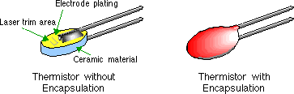

(NTC) refers to materials that experience a decrease in electrical resistance when their temperature is raised. Materials which have useful engineering applications usually show a relatively rapid decrease with temperature, i.e. a lower coefficient. The lower the coefficient, the greater a decrease in electrical resistance for a given temperature increase. T ↑ R ↓ I ↑

**Applications**

##### PTC

* + As current-limiting devices for circuit protection, as replacements for fuses. Current through the device causes a small amount of resistive heating. If the current is large enough to generate more heat than the device can lose to its surroundings, the device heats up, causing its resistance to increase. This creates a self-reinforcing effect that drives the resistance upwards, therefore limiting the current.
  + As timers in the degaussing coil circuit of most CRT displays. When the display unit is initially switched on, current flows through the thermistor and degaussing coil. The coil and thermistor are intentionally sized so that the current flow will heat the thermistor to the point that the degaussing coil shuts off in under a second. For effective degaussing, it is necessary that the magnitude of the alternating magnetic field produced by the degaussing coil decreases smoothly and continuously, rather than sharply switching off or decreasing in steps; the PTC thermistor accomplishes this naturally as it heats up. A degaussing circuit using a PTC thermistor is simple, reliable (for its simplicity), and inexpensive.
  + As heater in automotive industry to provide additional heat inside cabin with diesel engine or to heat diesel in cold climatic conditions before engine injection.
  + In temperature compensated synthesizer voltage controlled oscillators.
  + In lithium battery protection circuits.
  + In an electrically actuated Wax motor to provide the heat necessary to expand the wax.

##### NTC

* + As resistance thermometers in low-temperature measurements of the order of 10 K.
  + As inrush-current limiting devices in power supply circuits. They present a higher resistance initially which prevents large currents from flowing at turn-on, and then heat up and become much lower resistance to allow higher current flow during normal operation. These thermistors are usually much larger than measuring type thermistor, and are purposely designed for this application.
  + As sensors in automotive applications to monitor things like coolant or oil temperature inside the engine, and provide data to the ECU and to the dashboard.
  + To monitor the temperature of an incubator.
  + Thermistor are also commonly used in modern digital thermostats and to monitor the temperature of battery packs while charging.
  + Thermistor are often used in the hot ends of 3D printers; they monitor the heat produced and allow the printer's control circuitry to keep a constant temperature for melting the plastic filament.
  + In the Food Handling and Processing industry, especially for food storage systems and food preparation. Maintaining the correct temperature is critical to prevent food borne illness.
  + Throughout the Consumer Appliance industry for measuring temperature. Toasters, coffee makers, refrigerators, freezers, hair dryers, etc. all rely on thermistors for proper temperature control.
  + NTC thermistor come in bare and lugged forms, the former is for point sensing to achieve high accuracy for specific points, such as laser diode die, etc.

# Infrared Pyrometer

Infrared pyrometers allow users to measure temperature in applications where conventional sensors cannot be employed. Specifically, in cases dealing with moving objects (i.e., rollers, moving machinery, or a conveyer belt), or where non-contact measurements are required because of contamination or hazardous reasons (such as high voltage), where distances are too great, or where the temperatures to be measured are too high for thermocouples or other contact sensors.

The critical considerations for any infrared pyrometer include field of view (target size and distance), type of surface being measured (emissivity considerations), spectral response (for atmospheric effects or transmission through surfaces), temperature range and mounting (handheld portable or fixed mount). Other considerations include response time, environment, mounting limitations, viewing port or window applications, and desired signal processing.

### Infrared Thermometer Principle

Infrared thermometer is a non-contact temperature measurement device. It captures the invisible infrared energy emitted from all objects above absolute zero. The energy is then converted to an electrical signal after processing the electrical signal, it can be displayed in units of temperature.

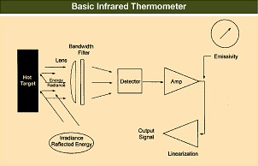

### Advantages

* + Measure temperature without any contact with the object
  + They facilitate measurement of moving targets.
  + Able to measure a wide range of temperature
  + Able to safely read hard-to-reach or inaccessible objects
  + Effectively read the temperature quickly and safety, saving time and cost
  + The accuracy is comparable with other contact types of thermometers
  + No risk of contamination and no mechanical effect on the surface of the object
  + Lightweight and compact
  + Easy to use
  + Fast Accurate Convenient Remote measurement No interference Wide temperature range

# RTD (2 Wire, 3 Wire and 4 Wire) connections

RTDs (Resistance Temperature Detectors) are offered with 2, 3, or 4 lead configuration. The best configuration for a specific application depends on a number of factors, however the sensor configuration must match instrumentation, otherwise lead wire resistance cancelation circuitry may be ineffective.

Factors to consider:

* + Cost of installation – more wires generally means higher cost
  + Available space – more or larger wires require more space
  + Accuracy requirements – 2 wire configurations may provide the required accuracy, especially with high resistance elements.

### Two Wire RTD

The simplest resistance thermometer configuration uses two wires. It is only used when high accuracy is not required, as the resistance of the connecting wires is added to that of the sensor, leading to errors of measurement. This configuration allows use of 100 meters of cable. This applies equally to balanced bridge and fixed bridge system.

For a balanced bridge the usual setting is with R2=R3 and R1 around the middle of the range of the RTD. So for example, if we are going to measure between 0ºC and 100ºC, RTD resistance will range from 100 ohm to 138, 5 ohm. We would choose R1=120 ohm. In that way we get a small measured voltage in the bridge.

The common values of resistance for a platinum RTD range from 10 ohms for the bird-cage model to several thousand ohms for the film RTD. The single most common value is 100 ohms at 0ºC. The DIN 43760 standard temperature coefficient of platinum wire is α = .00385. For a 100 ohm wire, this corresponds to + 0.385 ohms/ºC at 0ºC. This value for α is actually the average slope from 0ºC to 100ºC. The more chemically pure platinum wire used in platinum resistance standards has α of +.00392 ohms/ohm/ºC. Both the slope and the

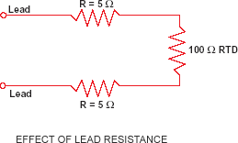

absolute value are small numbers, especially when we consider the fact that the measurement wires leading to the sensor may be several ohms or even tens of ohms. Small lead impedance can contribute a significant error to our temperature measurement. A ten ohm lead impedance implies 10/.385 ≈ 26ºC error in measurement. Even the temperature coefficient of the lead wire can contribute a measurable error. The classical method of avoiding this problem has been the use of a bridge.

### WIRE BRIDGE

In order to minimize the effects of the lead resistances, a three-wire configuration can be used. Using this method the two leads to the sensor are on adjoining arms. There is a lead resistance in each arm of the bridge so that the resistance is cancelled out, so long as the two lead resistances are accurately the same. This configuration allows up to 600 meters of cable.

As in the case with the 2-wire connection the usual setting is with R2=R3 and R1 around the middle of the range of the RTD.

If wires A and B are perfectly matched in length, their impedance effects will cancel because each is in an opposite leg of the bridge. The third wire, C, acts as a sense lead and carries no current.

The Wheatstone bridge shown in Figure creates a non-linear relationship between resistance change and bridge output voltage change. This compounds the already non-linear temperature-resistance characteristic of the RTD by requiring an additional equation to convert bridge output voltage to equivalent RTD impedance.

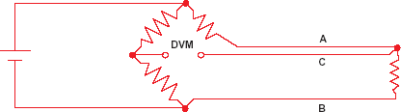

### Wire RTD

The four-wire resistance configuration increases the accuracy of measurement of resistance. Four-terminal sensing eliminates voltage drop in the measuring leads as a contribution to error. To increase accuracy further, any residual thermoelectric voltages generated by different wire types or screwed connections are eliminated by reversal of the direction of the 1 mA current and

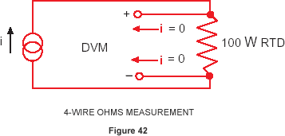

the leads to the DVM (Digital Voltmeter). The thermoelectric voltages will be produced in one direction only. By averaging the reversed measurements, the thermoelectric error voltages are cancelled out. The technique of using a current source along with a remotely sensed digital voltmeter alleviates many problems associated with the bridge. The output voltage read by the dvm is directly portioned to RTD resistance, so only one conversion equation is necessary. The three bridge-completion resistors are replaced by one reference resistor. The digital voltmeter measures only the voltage dropped

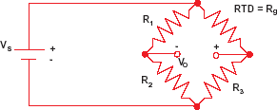

across the RTD and is insensitive to the length of the lead wires. The one disadvantage of using 4-wire ohms is that we need one more extension wire than the 3-wire bridge. This is a small price to pay if we are at all concerned with the accuracy of the temperature measurement.

### Wire Bridge Measurement Errors

If we know VS and VO, we can find Rg and then solve for temperature. The unbalance voltage Vo of a bridge built with R1 = R2 is:



If Rg = R3, VO= 0 and the bridge is balanced. This can be done manually, but if we don’t want to do a manual bridge balance, we can just solve for Rg in terms of VO:



This expression assumes the lead resistance is zero. If Rg is located some distance from the bridge in a 3-wire configuration, the lead resistance RL will appear in series with both Rg and R3:

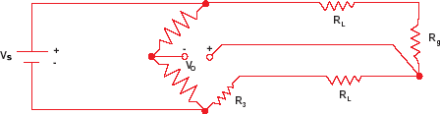

Again we solve for Rg:



The error term will be small if Vo is small, i.e., the bridge is close to balance. This circuit works well with devices like strain gauges, which change resistance value by only a few percent, but an RTD changes resistance dramatically with temperature. Assume the RTD resistance is 200 ohms and the bridge is designed for 100 ohms:

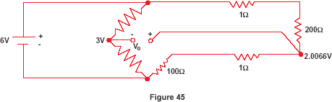

Since we don’t know the value of RL, we must use equation (a), so we get:



The correct answer is of course 200 ohms. That’s a temperature error of about 2.5ºC. Unless you can actually measure the resistance of RL or balance the bridge, the basic 3-wire technique is not an accurate method for measuring absolute temperature with an RTD. A better approach is to use a 4-wire technique.

**Applications of Temperature Measurement**

|  |
| --- |
| **Aluminium rolling**  Very different temperatures often occur in the various process stages. The corresponding Micro-Epsilon temperature sensors are used depending on the temperature range and application area |
| **Tempering - temperature measurement**  Stresses can occur during induction hardening which can be counteracted by heating up again to the tempering temperature. However, temperatures lower than those used for hardening are involved. |
| **Asphalt mixing systems - temperature measurement**  For temperature measurements in asphalt mixing systems, both the temperature of the mineral discharge and the temperature after mixing are measured. Infrared sensors from Micro-Epsilon are used for this |
| **Paper, packaging industry - temperature measurement**  Non-contact IR thermometers from Micro-Epsilon are used for fast and non-contact temperature measurement for the manufacture of paper products, particularly in the areas of  coating and drying and etc. |

# Level Measurement Level measurement

* Level measurement devices can detect, indicate, and/or help control liquid or solid

levels.

* Level measurement devices can be separated into two categories
  + Direct measurement and Electronic measurement.
* Level measurement devices can be used for continuous monitoring of fluid level, or for point-level monitoring.
* In point-level monitoring they are used to determine if the fluid level has exceeded a high point, which could cause a spill, or gone below a low point, which could mean the system is close to running on empty.

# Types of Level Measurements

There are different four types of Level measurement technique use.

* 1. Point level Measurement
  2. Continues Level Measurement
  3. Interface Level Measurement

### Point Level Measurements

In this types of level measurement there are different types of instruments available.

1. Capacitance type Level Instruments
2. Rotary paddle Type Level Instruments
3. Ultrasonic Level Instruments
4. Vibrating Level Instruments

### Continues Level Measurements

Many industrial processes require the accurate measurement of fluid or solid Height within a vessel.

1. Radar Level Instruments
2. Guided Wave radar Instruments
3. Ultrasonic Level Instruments
4. Gravimetric Level Instruments
5. Capacitance Level Instruments
6. Hydrostatic Level measurements

# Different Measuring Techniques

A wide variety of technologies exist to measure the level of substances in a vessel, Tank, Silos etc. Each exploiting a different principle of physics. This chapter explores the major level-measurement technologies in Current use.

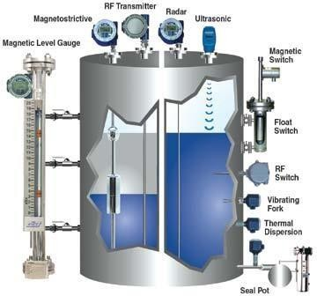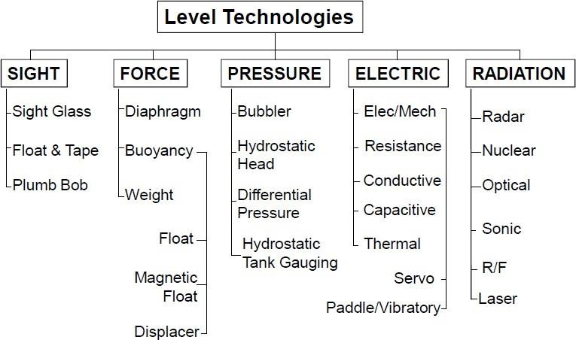

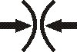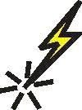

### All level measurement can be subdivided

|  |
| --- |
| **Sight** – viewable by eye |
| **Force** – material exerts force on an object |
| **Pressure** – material exerts head pressure |
| **Electric** – use of the measured materials electrical properties |
| **Radiation** – use of technologies in the electromagnetic spectrum |

**Level gauges (sight glasses)**

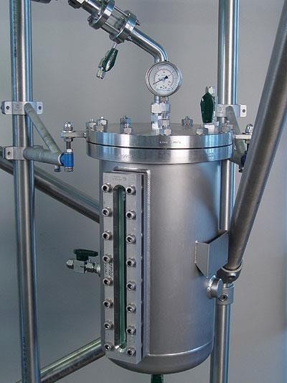

* Level gauges are perhaps the simplest indicating instrument for liquid level in a vessel.
* They are often found in industrial level- measurement applications, even when another level-measuring instrument is present, to serve as a direct indicator for an operator to monitor in case there is doubt about the accuracy of the other instrument.
* The level gauge, or sight-glass is to liquid level measurement as manometers are to pressure

Measurement: a very simple and effective technology for direct visual indication of process level.

* In its simplest form, a level gauge is nothing more than a clear tube through which process liquid may be seen.

### Functional diagram of Level Gauges (Sight glasses)

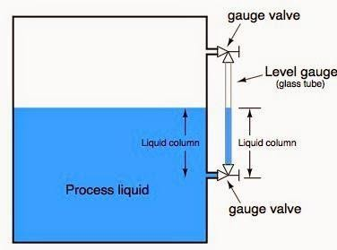

* Level gauge valves exist to allow replacement of the glass tube without emptying or depressurizing the process vessel.
* These valves are usually equipped with flow- limiting devices in the event of a tube rupture, so too much process fluid does not escape even when the valves are fully open.
* Some level gauges called reflex gauges are equipped with special optics to facilitate the viewing of clear liquids, which is problematic for simple glass-tube sight- glasses.

#### Drawback of this technique

* + A weakness of glass-tube level gauges is the glass tube itself.
  + The tube must be kept in a clean condition in order for the liquid level to be clearly visible, which may be a problem in a dirty-liquid service.
  + Also, glass tubes may rupture if subjected to thermal or mechanical shock.

### Float And tape

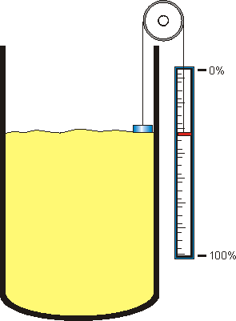

* + Perhaps the simplest form of solid or liquid level measurement is with a float: a device that rides on the surface of the fluid or solid within the storage vessel.
  + The float itself must be of substantially lesser density than the substance of interest, and it must not corrode or otherwise react with the substance.
  + Floats may be used for manual “gauging” of level, as illustrated here:
  + A person lowers a float down into a storage vessel using a flexible measuring tape, until

the tape goes slack due to the float coming to rest on the material surface.

* + At that point, the person notes the length indicated on the tape.
  + Once measurement is carried out then measured value is subtract from total vessel length.

#### Drawback of this technique

* + Obviously, this method of level measurement is tedious and may pose risk to the person conducting the measurement.
  + If the vessel is pressurized, this method is simply not applicable.

### Plumb Bob

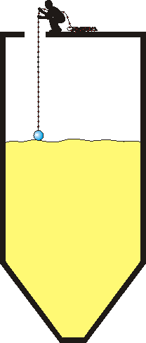

* + A worker drops a length of Pre-measured rope until a Float contacts the material Surface.

#### Advantage

* + Simple

#### Disadvantage

* + Human non-repeatability

### Hydrostatic pressure

* + A vertical column of fluid generates a pressure at the bottom of the column owing to the action of gravity on that fluid.

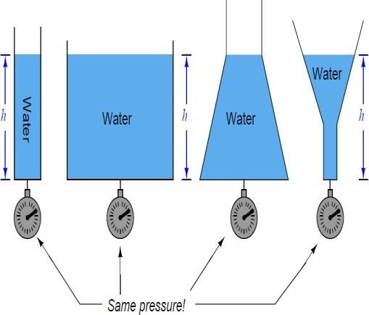

* + The greater the vertical height of the fluid, the greater the pressure, all other factors being equal.
  + The mathematical relationship between liquid column height and pressure is as follows:

##### P = ρgh P = γh

*Where,*

**P** = Hydrostatic pressure

**ρ** = Mass density of fluid in kilograms per cubic meter (metric) or slugs per cubic foot (British)

**g** = Acceleration of gravity

**γ** =Weight density of fluid in newton per cubic meter (metric) or pounds per cubic foot (British)

**h** = Height of vertical fluid column above point of pressure measurement

* + For example, the pressure generated by a column of oil 10 feet high (h) having a weight density of 50 pounds per cubic foot (γ) is:

##### P = γ h

P = 50 (lb/ft3) * 10 (ft)

= 500 lb/ft2

= (500 lb/ft2) * (1/144 ft2/in2)

= 3.47 lb/in2

= 3.47 PSI

* + Since the mathematical relationship between oil height and pressure is both linear and direct, the gauge’s indication will always be proportional to height.
  + A photograph showing the two lower pressure transmitters of a tank expert system on a refrigerated butane storage vessel appears here:

(The upper and lower instruments are pressure transmitters, while the middle instrument is a temperature sensor used to report the temperature of the refrigerated butane to the control system)

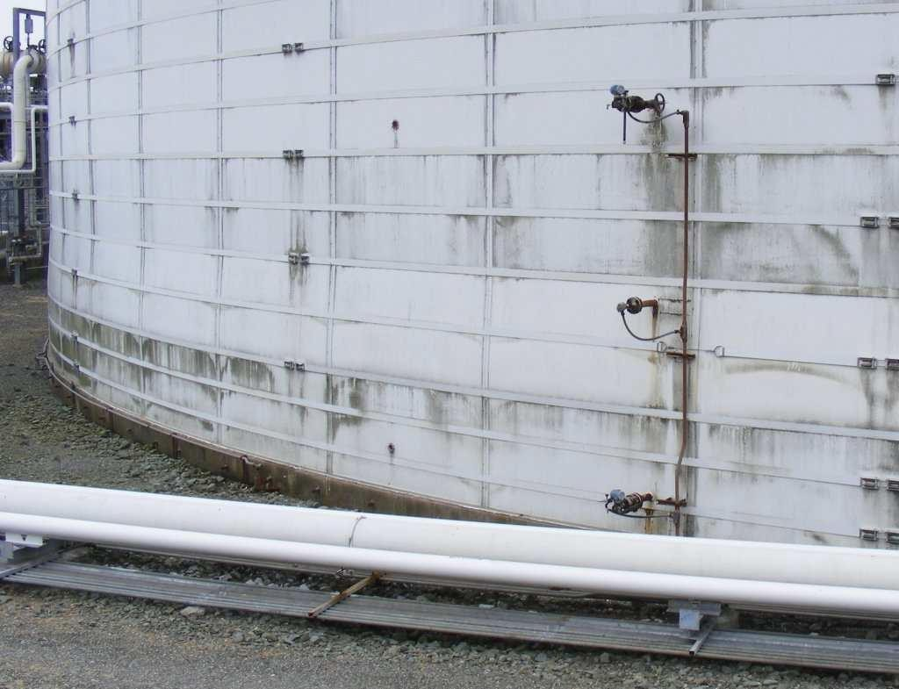

### Displacement level measurements

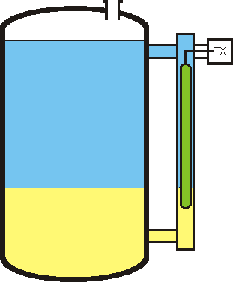

* Displacer level instruments exploit Archimedes’ Principle to detect liquid level by continuously measuring the weight of an object (called the displacer) immersed in the process liquid.
* As liquid level increases, the displacer experiences a greater buoyant force, making it appear lighter to the sensing instrument, which interprets the loss of weight as an increase in level and transmits a proportional output signal.

#### Advantage

* + Can detect air-liquid and
  + liquid-liquid interfaces

#### Disadvantage

* + Sensitive to density
  + change
  + Bulky
  + Not used on pressure

### Torque tubes

* + An interesting design problem for displacement-type level transmitters is how to transfer the sensed weight of the displacer to the transmitter mechanism while positively sealing process vapor pressure from that same mechanism.

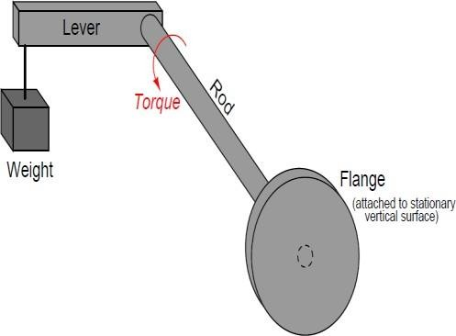

* + The most common solution to this problem is an ingenious mechanism called a torque tube.
  + Imagine a solid, horizontal, metal rod with a flange at one end and a perpendicular lever at the other end.
  + The flange is mounted to a stationary surface, and a weight suspended from the end of the lever.
  + A dashed-line circle shows where the rod is welded to the center of the flange.

### Ultrasonic level measurement

* + Ultrasonic level instruments measure the distance from the transmitter (located at some high point) to the surface of a process material located farther below using reflected sound waves.

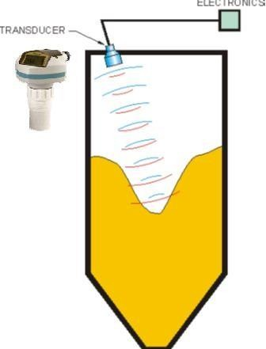

* + The frequency of these waves extend beyond the range of human hearing, which is why they are called ultrasonic.
  + The time-of-flight for a sound pulse indicates this distance, and is interpreted by the transmitter electronics as process level.
  + These transmitters may output a signal corresponding either to the fullness of the vessel or the amount of empty space remaining at the top of a vessel.
  + Vessel is the “natural” mode of measurement for this sort of level instrument, because the sound wave’s time-of-flight is a direct function of how much empty space exists between the liquid surface and the top of the vessel.

### Bubbler level measurement

* + An interesting variation on this theme of direct hydrostatic pressure measurement is the use of a purge gas to measure hydrostatic pressure in a liquid-containing vessel.

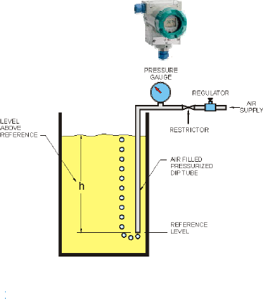

* + This eliminates the need for direct contact of the process liquid against the pressure-sensing element, which can be advantageous if the process liquid is corrosive.
  + Such systems are often called bubble tube or dip tube systems, the former name being

appropriately descriptive for the way purge gas bubbles out the end of the tube as it is submerged in process liquid.

* + A small volume of compressed air is injected by a long tube to the bottom of the vessel.
  + The backpressure is proportional to level.
  + Excessive purge gas flow through the tube will result in additional pressure caused by frictional pressure drop along the tube’s length, causing the pressure-sensing instrument to falsely register high.

### Electromagnetic Level Measurement

The flow measuring principle is based on Faraday’s law of electromagnetic induction.

* + *Where*

Ui = When an electrical conductor of length L is moved at velocity v, perpendicular to the lines of flux through a magnetic field of strength

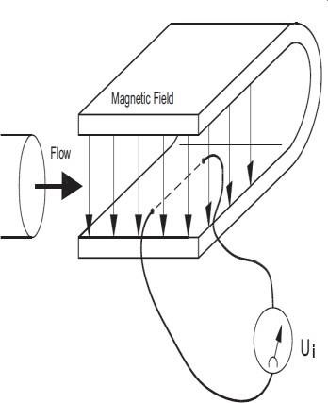

B, the voltage Ui is induced at the ends of the conductor

##### Ui = L x B x v

Ui = Induced voltage

L = Conductor length = Inner pipe diameter = k1 B = Magnetic field strength = k2

V = Velocity of conductor (media) k = k1 x k2

Ui = k x v, the electrode signal is directly proportional to the fluid velocity

* + The coil current module generates a pulsating magnetizing current that drives the coils in the sensor.
  + The current is permanently monitored and corrected.
  + Errors or cable faults are registered by the self-monitoring circuit.
  + Input circuit amplifies the flow-proportional induced voltage signal from the electrodes.
  + The input impedance is extremely high: >1014 Ω which allows flow measurements on fluids with conductivities as low as 5 μS/cm.

### Echo technology

* + Measures time of flight from transmission to received echo. This determines distance and infer level.
  + A completely different way of measuring liquid level in vessels is to bounce a traveling wave off the surface of the liquid – typically from a location at the top of the vessel – using the time-of-flight for the waves as an indicator of distance and therefore an indicator of liquid height inside the vessel.
  + Liquid-liquid interfaces may also be measured with some types of echo-based level instruments, most commonly guided-wave radar.

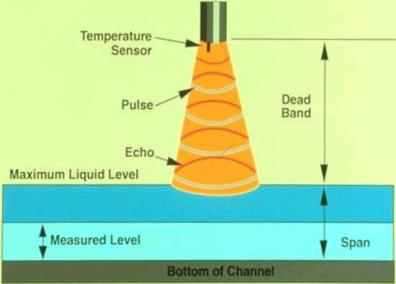

* + The single most important factor to the accuracy of an echo-based level instrument is the speed at which the wave travels en route to the liquid surface and back.
  + For ultrasonic (sound) echo instruments, the speed of sound is a function of medium density.
  + For radar (radio wave) echo instruments, the speed of radio wave propagation varies according to the dielectric permittivity of the medium.
  + Permittivity is also affected by changes in density for the fluid medium, and so even radar level instruments may suffer calibration drift with process fluid density changes.

### Radar level measurement

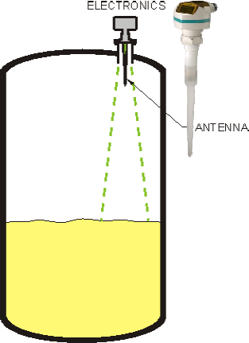

* + Radar level instruments measure the distance from the transmitter (located at some high point) to the surface of a process material located farther below in much the same way as ultrasonic transmitters – by measuring the time-of- flight of a traveling wave.
  + The fundamental difference between a radar instrument and an ultrasonic instrument is the type of wave used: radio waves instead of sound waves. Radio waves are electromagnetic in nature (comprised of alternating electric and magnetic fields), and very high frequency

(in the microwave frequency range – GHz).

* + Sound waves are mechanical vibrations (transmitted from molecule to molecule in a fluid or solid substance) and of much lower frequency (tens or hundreds of kilohertz – still too high for a human being to detect as a tone) than radio waves.
  + Non-contact radar transmitters are always mounted on the top side of a storage vessel. Modern radar transmitters are quite compact,

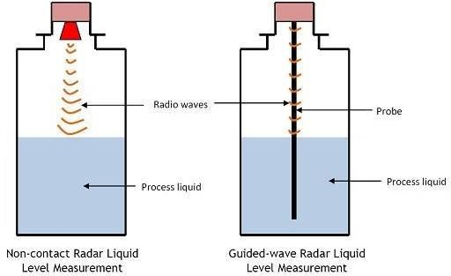

### Laser level measurement

* + The least-common form of echo-based level measurement is laser, which uses pulses of laser light reflected off the surface of a liquid to detect the liquid level.
  + Perhaps the most limiting factor with laser measurement is the necessity of having a sufficiently reflective surface for the laser light to “echo” off of.
  + Many liquids are not reflective enough for this to be a practical measurement technique, and the presence of dust or thick vapors in the space between the laser and the liquid will disperse the light, weakening the light signal and making the level more difficult to detect.
  + However, lasers have been applied with great success in measuring distances between objects.

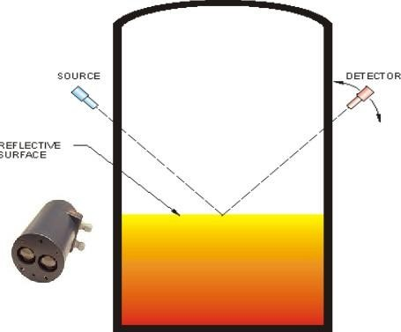

* + Applications of this technology include motion control on large machines, where a laser points at a moving reflector, the laser’s electronics calculating distance to the reflector based on the amount of time it takes for the laser “echo” to return.

### Optical level measurements

* + Uses the refractive index of a liquid to sense a point level.

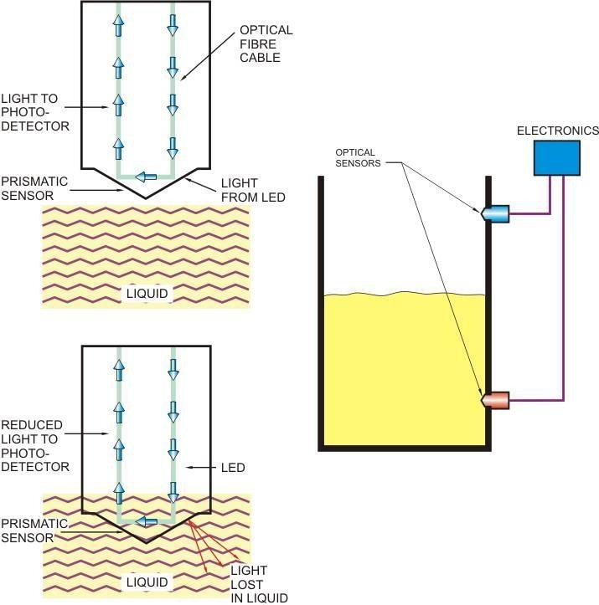

#### Advantage

* + Inexpensive

#### Disadvantage

* + Can only be
  + used for point

### Weight base level Measurement

* + Weight-based level instruments sense process level in a vessel by directly measuring the weight of the vessel. If the vessel’s empty weight (tare weight) is known, process weight becomes a simple calculation of total weight minus tare weight.

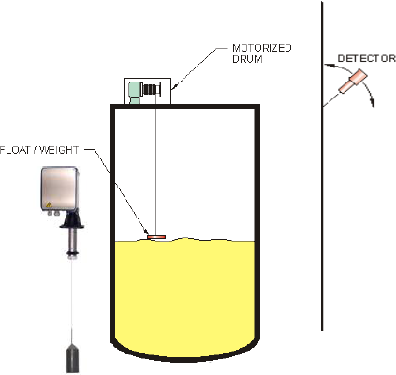

* + Obviously, weight-based level sensors can measure both liquid and solid materials, and they have the benefit of providing inherently linear mass storage Measurement.
  + Load cells (strain gauges bonded to a steel element of precisely

known modulus) are typically the primary sensing element of choice for detecting vessel weight.

* + As the vessel’s weight changes, the load cells compress or relax on a microscopic scale, causing the strain gauges inside to change resistance.
  + These small changes in electrical resistance become a direct indication of vessel weight.
  + The following photograph shows three bins used to store powdered milk, each one supported by pillars equipped with load cells near their bases:

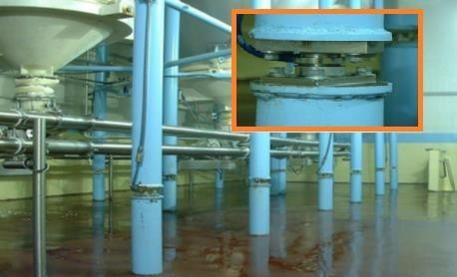

### Capacitive Level Measurement

* + Capacitive level instruments measure electrical capacitance of a conductive rod inserted vertically into a process vessel. As process level increases, capacitance increases between the rod and the vessel walls, causing the instrument to output a greater signal.

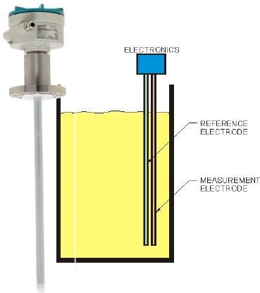

*Where*,

𝐶 =

∈ 𝐴

𝐷

C = Capacitance

∈ = Permittivity of dielectric (insulating) material between plates

A = Overlapping area of plates d = Distance separating plates

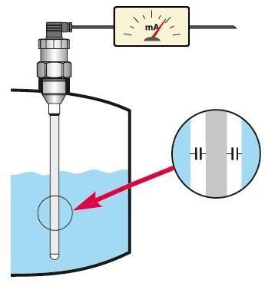

* + Capacitive level probes come in two basic varieties: one for conductive liquids and one for nonconductive liquids.
  + If the liquid in the vessel is conductive, it cannot be used as the dielectric (insulating) medium of a capacitor.

### Inductive level measurement

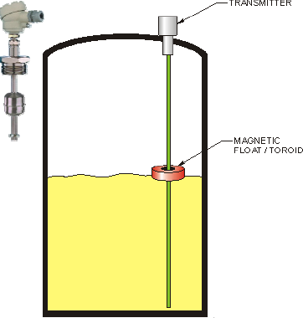

* + Similar to magnetic float except float contains toroid and uses inductance.

#### Advantage

* + Low cost

#### Disadvantage

* + Easily damaged
  + Point level only

# Flow Measurement Flow measurement

* + Flow measurement is the quantification of bulk fluid movement.
  + Flow can be measured in a variety of ways.
  + Positive-displacement flow meters accumulate a fixed volume of fluid and then count the number of times the volume is filled to measure flow.
  + Other flow measurement methods rely on forces produced by the flowing stream as it overcomes a known constriction, to indirectly calculate flow.
  + Flow may be measured by measuring the velocity of fluid over a known area.

# Units of Flow Measurement

* + Both gas and liquid flow can be measured in volumetric or mass flow rates, such as liters per second or kilograms per second, respectively.
  + These measurements are related by the material's density.
  + The density of a liquid is almost independent of conditions.
  + This is not the case for gasses, the densities of which depend greatly upon pressure, temperature and to a lesser extent, composition
  + When gases or liquids are transferred for their energy content, as in the sale of natural gas, the flow rate may also be expressed in terms of energy flow, such as GJ/hour or BTU/day.
  + The energy flow rate is the volumetric flow rate multiplied by the energy content per unit volume or mass flow rate multiplied by the energy content per unit mass.
  + Energy flow rate is usually derived from mass or volumetric flow rate by the use of a flow computer.
  + In engineering contexts, the volumetric flow rate is usually given the symbol Q, and the mass flow rate, the symbol.
  + For a fluid having density Þ, mass and volumetric flow rates may be related by \dot m

= \Þ*Q.

# Factor Affecting on Flow Measurement

The major factors affecting the flow of fluids are:

##### The velocity of the fluid

* + Fluid velocity depends on the head pressure which is forcing the fluid through the pipe.
  + The greater the head pressure, the faster the fluid flow rate (all other factors remaining constant), and consequently, the greater the volume of flow.
  + Pipe size also affects the flow rate. For example, doubling the diameter of a pipe increases the potential flow rate by a factor of four times.

##### The friction of the fluid in contact with the pipe

* + Pipe friction reduces the flow rate of fluids through pipes and is, therefore, considered a negative factor.
  + Because of the friction of a fluid in contact with a pipe, the flow rate of the fluid is slower near the walls of the pipe than at the center.
  + The smoother, cleaner, and larger a pipe is, the less effect pipe friction has on the overall fluid flow rate.

##### The viscosity of the fluid.

* + Viscosity (m), or the molecular friction within a fluid, negatively affects the flow rate of fluids.
  + Viscosity and pipe friction decrease the flow rate of a fluid near the walls of a pipe.
  + Viscosity increases or decreases with changing temperature, but not always as might be expected.
  + In liquids, viscosity typically decreases with increasing temperature.

##### The density of the fluid.

* + Density (r) of a fluid affects flow rates in that a more dense fluid requires more head pressure to maintain a desired flow rate.
  + Also, the fact that gases are compressible, whereas liquids essentially are not, often requires that different methods be used for measuring the flow rates of liquids, gases, or liquids with gases in them.
  + It has been found that the most important flow factors can be correlated together into a dimensionless parameter called the Reynolds number, which describes the flow for all velocities, viscosities, and pipeline sizes.
  + In general, it defines the ratio of velocity forces driving the fluid to the viscous forces restraining the fluid, or:



* + At very low velocities of high viscosities, Re is low and the fluid flows in smooth layers with the highest velocity at the center of the pipe and low velocities at the pipe wall where the viscous forces restrain it.
  + This type of flow is called laminar flow and is represented by Reynolds numbers below 2,000. One significant characteristic of laminar flow is the parabolic shape of its velocity profile.

# Types of Flow

There are in general three types of fluid flow in pipes

1. Laminar Flow
2. Turbulent Flow
3. Transitional Flow

##### Laminar Flow

* + Laminar flow generally happens when dealing with small pipes and low flow velocities.

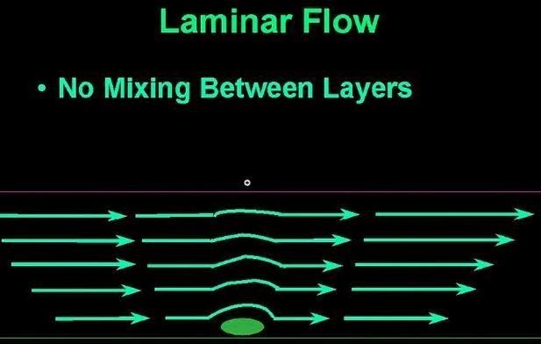

* + Laminar flow can be regarded as a series of liquid cylinders in the pipe, where the innermost parts flow the fastest, and the cylinder touching the pipe isn't moving at all.
  + Shear stress in a laminar flow depends almost only on viscosity - μ - and is independent of density - ρ.

##### Turbulent Flow

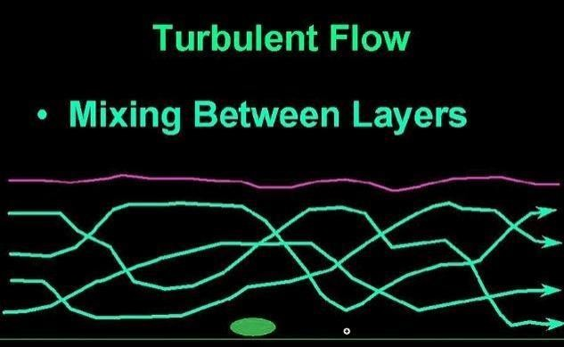

* + In turbulent flow vortices, eddies and wakes make the flow unpredictable.
  + Turbulent flow happens in general at high flow rates and with larger pipes. Shear stress in a turbulent flow is a function of density - ρ.

##### Transitional Flow

* + Transitional flow is a mixture of laminar and turbulent flow, with turbulence in the center of the pipe, and laminar flow near the edges.
  + Each of these flows behave in different manners in terms of their frictional energy loss while flowing and have different equations that predict their behaviour.
  + Turbulent or laminar flow is determined by the dimensionless Reynolds Number.
  + The Reynolds number is important in analysing any type of flow when there is substantial velocity gradient (i.e. shear.) It indicates the relative significance of the viscous effect compared to the inertia effect.
  + The Reynolds number is proportional to inertial force divided by viscous force.
  + The flow is
    - Laminar when Re < 2300
    - Transient when 2300 < Re < 4000
    - Turbulent when 4000 < Re

# Types of Flow Measurement devices

* + Fluid flow devices fall into a number of device categories as well as fluid classes.
  + In general we can split the fluids into two classes; gasses and liquids
  + The physical measurement devices come in a number of classifications.
  + While the following classifications do not match any industry standards, they serve to break the transducers down into some reasonably functional groups.

These are:

* + - Obstruction flow meters
    - Velocity flow meters – Including Moving Member meters
    - Positive Displacement meters
    - Variable area meters
    - Electronic meters
  + In the Process Industries, It is often necessary to measure fluid flow. The Most Common Type of Measurement for Liquids & Gases are
    - Absolute Quantities (based on total gallons or litters, Time or rate is not consider)
    - Percentage Flow rate (Percentage flow for specified time period)
    - Volumetric Flow rate (Volumetric flow for specified time period)
    - Mass Flow (Mass flow for specified time period)

### Rotary Piston Meter

* + The oscillating rotary piston divides the measured liquid into accurately defined subsets, which together form the measuring chamber volume.

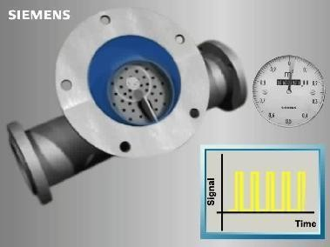

* + Once with every ring butt rotation the measuring chamber volume is edged out.
  + The circulation of the rotary piston is transferred by a magnet clutch, free of sealed bushing to drum-type counters and registers.
  + Rotary piston flow meter application examples: Petroleum industry, Raw material industry
  + For each rotation, an amount of water passes through the piston chamber. Through a gear mechanism and, sometimes, a magnetic drive, a needle dial and odometer type display are advanced.

#### Advantages:

* + Accuracy (custody transfer measurements)
  + Batch processes
  + High-and low-viskose media (to 3,500.000 mPa.s)
  + Aggressive media
  + Mobile applications (without auxiliary power)
  + No undisturbed in-and outlet straight length needed (installation on vehicles)
  + Operating temperature to 300°C (thereby heating)
  + Smaller solid particles possible
  + Durable

#### Disadvantages:

* + Pressure loss
  + Mobile parts
  + Expensive for big pipe diameters
  + Flow limit for every pipe diameter
  + Wearing from abrasive media

### Variable Area Flow meters

* A variable area flow meter is one of the simplest of flow measurement methods.

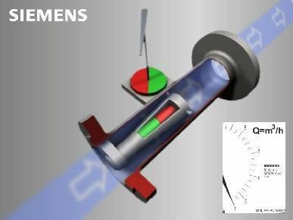

* Suitable for both gasses and liquids, the meter contains a custom-made flow tube that slowly flares out as it rises
* The direction of flow in the vertical conic tube is from the bottom to the top.
* The upward flowing media lifts the float for as long as necessary to reach an equilibrium.

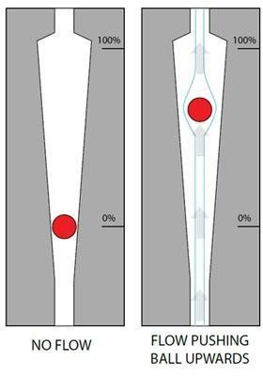

* The ring shaped gap between the measuring tube and the reading edge of the float is just big enough so that the state of suspense is achieved
* As your flow enters the lower chamber and moves upwards, it forces the ball upwards against the force of gravity.
* Thanks to the shape of the tube, the ball moves up in a linear relation to flow rate, giving you a surprisingly accurate mechanical indicator.
* Variable area indicators are ideal for clean, clear liquids and gasses.

#### Advantages:

* + Reasonably priced, simple construction
  + No auxiliary energy necessary
  + Suitable for liquids and gases
  + No in-and outlet straight length necessary
  + Assembly and maintenance friendly
  + Available with contact or current exit

#### Disadvantages:

* + Vertical installation
  + Pressure loss
  + Solids can damage measuring edge
  + Pressure, temperature and density dependant
  + Sensitive against pulsation or vibration
  + Wearing from abrasive media

### Coriolis Single Bent Tube

* The single bent tube sensor consist of a single pipe, bended twice to form a parallel omega loop, all fixed by a center block in the middle.

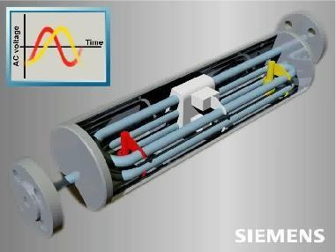

* The sensor tubes are put into oscillation by an electromagnet which oscillates the pipe at its resonant frequency.
* Two pick-up’s, are placed symmetrically either side of the driver.
* When liquid or gas flows through the sensor, Coriolis force will act on the measuring pipe and cause a pipe deflection which can be measured as a phase shift on pick-up 1 and 2. The phase shift is proportional to the mass flow rate, hence at zero mass flow there will be no phase difference.
* When flow starts to flow, a phase difference between the two pickups will be created, proportional to the mass flow rate.

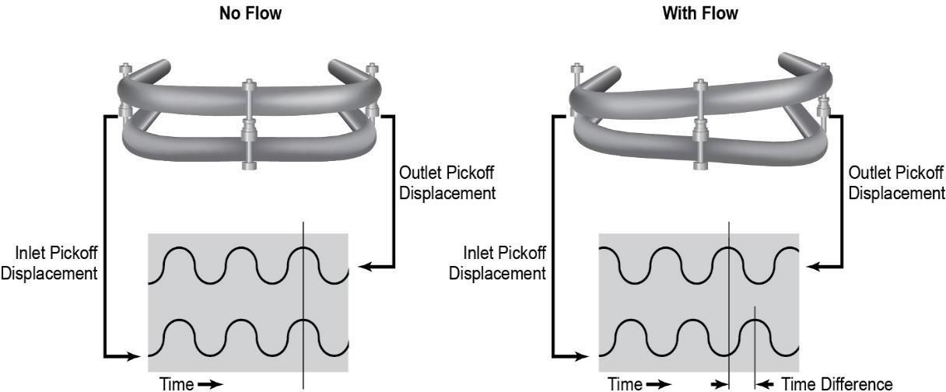

### Magnetic Inductive AC

* Always the same as for measurements in the pulsed DC procedure. With the pulsed AC, the magnetic coils are supplied with comparatively high mains voltage (115 V AC or 230 V AC).
* Thereby one gets 5 -10 times bigger signal voltage compared to pulsed DC devices.
* The influence of the fluctuating net voltages, coil temperatures and magnetic properties of the media will be eliminated by the measurement of the magnetic field, with the help of an additional reference coil.
* The third most common flow meter displacement flow meters) is the

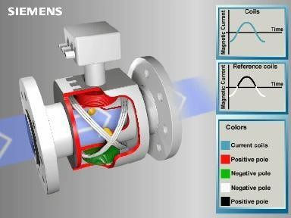

(behind differential pressure and positive magnetic flow meter, also technically

an electromagnetic flow meter or more commonly just called a mag meter.

* A magnetic field is applied to the metering tube, which results in a potential difference proportional to the flow velocity perpendicular to the flux lines.
* The physical principle at work is electromagnetic induction.
* The magnetic flow meter requires a conducting fluid, for example, water that contains ions, and an electrical insulating pipe surface, for example, a rubber-lined steel tube.

#### Advantages:

* + As for pulsed DC procedure, additional:
  + Measurements of 2-phase media (e.g., paper pulp, media with high solid interests)
  + Measurements of low conductivity liquids(> 0.008 μ S/cm, with VE-water> 3 μ S/cm)
  + Measurements with pulsating currents
  + Measurements of small flow velocity speeds, from 0.15 m/s / 0.492 m/s

#### Disadvantages:

* + Not suitable for the measurement of gases, foam and none conductive media
  + Depending on the measurement method, the pipe must be either filled completely or not.

### Ultrasonic Doppler

* After the Doppler procedure, the ultrasonic flow meter sends out an ultrasonic signal (usually 1 to 5 MHz) in an angle in the measuring tube.

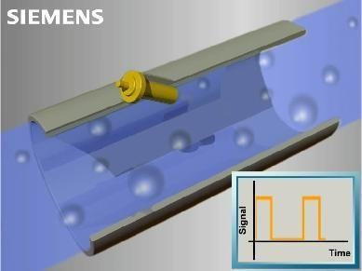

* Parts of these ultrasonic signals send reflecting particles (e.g., dirt, gas, air bubbles, and cords of the flow) back to the receiver.
* The reflected float moves in the direction of, or away from the sender, the frequency of the returned signal deviates from the original signal (Doppler effect)
* An ultrasonic flow meter is a type of flow meter that measures the velocity of a fluid with ultrasound to calculate volume flow.
* Using ultrasonic transducers, the flow meter can measure the average velocity along the path of an emitted beam of ultrasound, by averaging the difference in measured transit time between the pulses of ultrasound propagating into and against the direction of the flow or by measuring the frequency shift from the Doppler Effect.
* There are three different types of ultrasonic flow meters.
* Transmission (or contra propagating transit-time) flow meters can be distinguished into in-line (intrusive, wetted) and clamp-on (non-intrusive) varieties.
* Ultrasonic flow meters that use the Doppler shift are called Reflection or Doppler flow meters. The third type is the Open-Channel flow meter.
* With the transit time procedure, the time is measured in which a sound wave takes to get around path 1. I.e. point A, the sender to point B, the receiver (in the direction of flow) or back (against the direction of flow).
* The electrical acoustic converters (based on the Piezo effect) are built in at different places on both sides of the measuring tube.

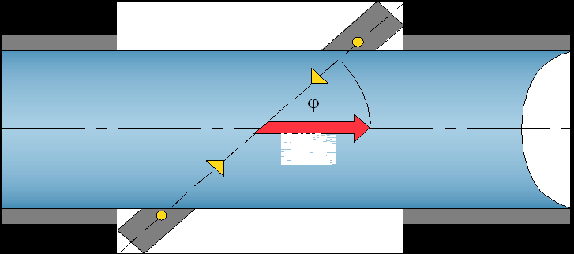

* These therefore apply:

C1 = C0 + v and C2 = C0 -v

C0 = speed of sound in the unmaneuverable liquid V = flow velocity speed in the measuring tube

#### Advantages:

* + Simple assembly of existing pipes
  + Not intrusive, no maneuverable parts, no pressure loss
  + Wear free
  + Suitable for media with solid interest

#### Disadvantages:

* + The speed of the particles and the reflecting and scattering effect can generate false measurements
  + Speed of sound of the particle material must strongly differ from that of the Fluids
  + High flow velocity speed of the media is essential, otherwise the particles tend to rest in the pipes.
  + Ultrasonic field is frequently deflected directly in the boundary current. Thereby, strong dependence on the flow profile

### Effective Pressure

* The tube diameter constricted in a restrictor. The fluid flowing through simultaneously gains speed and loses pressure. The pressure change between entrance and exit of the restrictor is known as the differential pressure or delta P.

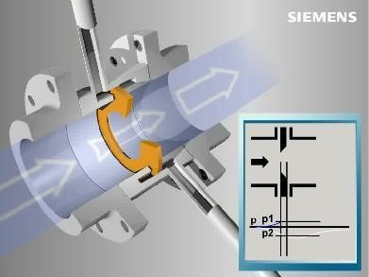

* A relationship can be drawn between the differential pressure and the mass flow and/or volume flow based on Bernoulli's energy equation, Euler's law of continuity and the relationship between the diameters before and inside the restrictor.
* By measuring the differential pressure and then using the calculation the flow is established at the restrictor.

#### Advantages

* + Designed for steam, gas und liquid
  + Use at user-defined pressure and temperature
  + Widespread measuring process
  + No calibration necessary
  + Robust process
  + Easy adaptation to changed process data by
  + Calculation or transceiver recalibration.
  + The device can be individually adjusted to the
  + Measuring point data by variance of the
  + Calculation and various installation options

#### Disadvantages

* + Loss of pressure
  + Inflow and outflow zones
  + Single-phase media only
  + Quadratic curve
  + Measuring range 10 -100%
  + Not designed for highly viscous media
  + Temperature corrections and/or pressure
  + Fluctuation necessary

### Application of Flow Measurements

* + HVAC and Energy
  + Utilities monitoring
  + Water/glycol solutions
  + Water Management
  + Pump monitoring
  + River water
  + Food + Process Industries
  + Chemical Flow
  + Agriculture Industries
  + Open Channel & close Channel flow
  + Dairy products
  + Sludge and slurries.

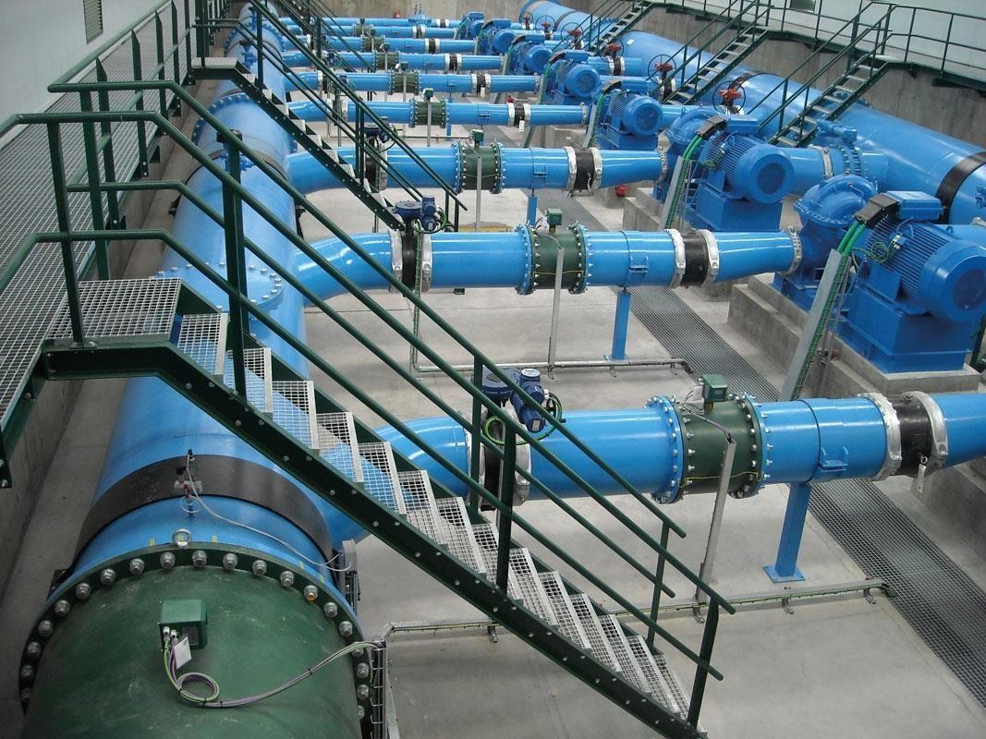

# Communication Protocol Profibus

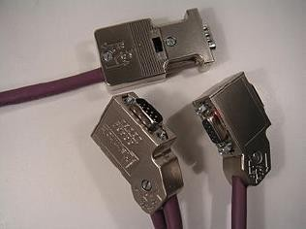

(Process Field Bus) is a standard for fieldbus communication in automation technology and was first promoted in 1989 by BMBF (German department of education and research) and then used by Siemens. It should not be confused with the PROFINET standard for Industrial Ethernet. PROFIBUS is openly published as part of IEC 61158.

### Origin

The history of PROFIBUS goes back to a publicly promoted plan for an association which started in Germany in 1986 and for which 21 companies and institutes devised a master project plan called "fieldbus". The goal was to implement and spread the use of a bit-serial field bus based on the basic requirements of the field device interfaces. For this purpose, member companies agreed to support a common technical concept for production (i.e. discrete or factory automation) and process automation. First, the complex communication protocol Profibus FMS (Field bus Message Specification), which was tailored for demanding communication tasks, was specified. Subsequently in 1993, the specification for the simpler and thus considerably faster protocol PROFIBUS DP (Decentralized Peripherals) was completed. Profibus FMS is used for (non-deterministic) communication of data between Profibus Masters. Profibus DP is a protocol made for (deterministic) communication between Profibus masters and their remote I/O slaves. There are two variations of PROFIBUS in use today; the most commonly used PROFIBUS DP, and the lesser used, application specific, profibus PA

### Profibus DP

(Decentralized Peripherals) is used to operate sensors and actuators via a centralized controller in production (factory) automation applications.

* The many standard diagnostic options, in particular, are focused on here.

### Profibus PA

(Process Automation) is used to monitor measuring equipment via a process control system in process automation applications.

* This variant is designed for use in explosion/hazardous areas (Ex-zone 0 and 1).
* The Physical Layer (i.e. the cable) conforms to IEC 61158-2, which allows power to be delivered over the bus to field instruments, while limiting current flows so that explosive conditions are not created, even if a malfunction occurs.
* The number of devices attached to a PA segment is limited by this feature. PA has a data transmission rate of 31.25 Kbit/s. However, PA uses the same protocol as DP, and can be linked to a DP network using a coupler device.
* The much faster DP acts as a backbone network for transmitting process signals to the controller.
* This means that DP and PA can work tightly together, especially in hybrid applications where process and factory automation networks operate side by side. In excess of 30 million PROFIBUS nodes were installed by the end of

2009. 5 million of these are in the process industries.

# HART Communications Protocol

##### (Highway Addressable Remote Transducer Protocol)

* It is an early implementation of Fieldbus, a digital industrial automation protocol.

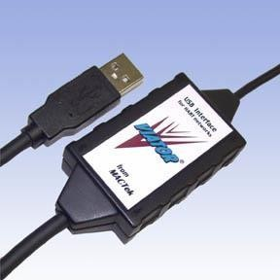

* It is most notable advantage is that it can communicate over legacy 4-20 mA analog instrumentation wiring, sharing the pair of wires used by the older system.
* According to Emerson due to the huge installed base of 4–20 mA systems throughout the world, the HART Protocol is one of the most popular industrial protocols today.
* HART protocol has made a good transition protocol for users who were

comfortable using the legacy 4–20 mA signals, but wanted to implement a "smart" protocol

* HART protocol has made a good transition protocol for users who were comfortable using the legacy 4–20 mA signals, but wanted to implement a "smart" protocol
* The protocol was developed by Rosemount Inc., built off the Bell 202 early communications standard, in the mid-1980s as proprietary digital communication protocol for their smart field instruments. Soon it evolved into HART. In 1986, it was made an open protocol. Since then, the capabilities of the protocol have been enhanced by Successive revisions to the specification.

**Modes**

There are two main operational modes of HART instruments:

1. Analog/digital mode
2. Multi drop mode.

##### Point-to-point mode (analog/digital)

The digital signals are overlaid on the 4-20 mA loop current. Both the 4-20 mA current and the digital signal are valid output values from the instrument. The polling address of the instrument is set to "0". Only one instrument can be put on each instrument cable signal pair. One signal, generally specified by the user, is specified to be the 4-20 mA signal. Other signals are sent digitally on top of the 4-20 mA signal. For example, pressure can be sent as 4-20 mA, representing a range of pressures, and temperature can be sent digitally over the same wires. In point-to-point mode, the digital part of the HART protocol can be seen as a kind of digital current loop interface.

##### Multi drop mode (digital)

Only the digital signals are used. The analog loop current is fixed at 4 mA. In multi drop mode it is possible to have more than one instruments on one signal cable. HART revisions 3 through 5 allowed polling addresses of the instruments to be in the range 1–15. HART 6 and later allowed address up to 63. Each instrument needs to have a unique address.

# Foundation Fieldbus

* + FOUNDATION Fieldbus is an all-digital, serial, two-way communications system that serves as the base-level network in a plant or factory automation environment.
  + It is an open architecture, developed and administered by the Fieldbus Foundation.
  + It is targeted for applications using basic and advanced regulatory control, and for much of the discrete control associated with those functions.
  + Foundation fieldbus technology is mostly used in process industries, but has recently been implemented in power plants.
  + Two related implementations of FOUNDATION fieldbus have been introduced to meet different needs within the process automation environment.
  + These two implementations use different physical media and communication speeds.
    - **FOUNDATION Fieldbus H1**

1. Operates at 31.25 kbit/s and is generally used to connect to field devices and host systems.
2. It provides communication and power over standard stranded twisted-pair wiring in both conventional and intrinsic safety applications.
3. H1 is currently the most common implementation.
   * + **HSE (High-speed Ethernet)**
4. Operates at 100/1000 Mbit/s and generally connects input/output subsystems, host systems, linking devices and gateways.
5. It doesn't currently provide power over the cable, although work is under way to address this using the IEEE802.3af Power over Ethernet (PoE) standard.

# CAN open

* + CAN open is a communication protocol and device profile specification for embedded systems used in automation.
  + In terms of the OSI model, CAN open implements the layers above and including the network layer.
  + The CAN open standard consists of an addressing scheme, several small communication protocols and an application layer defined by a device profile.
  + The communication protocols have support for network management, device monitoring and communication between nodes, including a simple transport layer for message segmentation/de segmentation.
  + The lower level protocol implementing the data link and physical layers is usually Controller Area Network (CAN), although devices using some other means of communication (such as Ethernet Power link, Ether CAT) can also implement the CAN open device profile.

# Profinet

* + PROFINET (Process Field Net) is a standard for Industrial Ethernet based on Industrial Ethernet according to IEEE 802.xx.
  + Three protocol levels are defined:

1. TCP/IP for PROFINET CBA and the commissioning of a plant with reaction times in the range of 100 ms
2. RT (real-time) protocol for PROFINET CBA and PROFINET IO applications up to 10 ms cycle times
3. IRT (Isochronous Real-Time) for PROFINET IO applications in drive systems with cycles times of less than 1 ms
   * The protocols can be recorded and displayed using an Ethernet analysis tool such as Wire shark.
   * The topology can be shown using analysis tools such as TH Scope.
   * Every module within a PROFINET network has three addresses:
4. MAC address
5. IP address
6. Device name, a logical name for the module within the total configuration
   * Because PROFINET uses TCP/IP a MAC and IP address are used.
   * A MAC address changes if the device is replaced.
   * An IP address is a form of dynamic addressing.
   * Because there was a need for a fixed address a device name is used.

Simatic PDM software

Siemens SIMATIC PDM (Process Device Manager)

* + **SIMATIC PDM** is a universal tool for configuration, parameter assignment commissioning, diagnostics and maintenance of intelligent process devices and automation components.
  + With PDM, you can use a single interface to configure field devices from a number of different manufacturers.
  + Process data can be easily set, changed, tested, managed and simulated.
  + We can also use PDM to monitor process values, alarms and status signals of online devices
  + Key Specifications
    - Simple, operating system-independent integration of field devices based on device descriptions (e.g. HART DD)
    - Similar visualization of all field devices
    - Provides basic functions (e.g. export, data comparison, printing) for all Siemens field devices
    - Communication with PROFIBUS PA, PROFIBUS DP, HART or Modbus
    - No configuration knowledge required for parameter assignment and diagnostics of field devices via the Life List
    - Type-independent and cross-manufacturer field device parameter assignment and diagnostics

# EDD File

Electronic device description (EDD) is a proven way to describe behavior and functionality of field instruments and other components

# Field device configuration steps in Simatic PDM

### Steps for HART protocol based devices

#### Requirements:

1. Hart modem with its drivers
2. 250ohm load
3. EDD Files of respective devices
4. Simatic manager

#### Steps

1. Open **Simatic manager**
2. Go to **File** > **New**
3. Give project name and source directory and press **ok**
4. Now go to **View** and select **Process device and network view**
5. Go to **options** > set **PG/PC interface** > **select USB S7.1** > **ok**
6. **Right click** on your project > select **insert new object**> **network**s
7. Right click on **networks** > **insert new object** > **communication networks**
8. Select **assign device type** > select **hart modem** in hart > ok
9. NOW select your PC name (created with hart modem in project window)
10. Double click on **com port interface** >**general** >enter **COM Port number** in place of “COM port” (find com port number in device manager) > **ok**
11. Right click on **hart modem network** > **insert new object** >**assign device type**> click **device identifications** (or select your device manually) >**ok**
12. Right click on your device > **Open object** > go to **view** > select **process variables**

### Steps for PA protocol based device

#### Requirements:

1. PA/ DP coupler
2. Profibus DP cable
3. CP5711 communication modem
4. EDD files of respective devices
5. Simatic manager

#### Steps:

1. Open **Simatic manager**
2. Go to **File** > **New**
3. Give **project name** and **source directory** and press **ok**
4. Now go to **View** and select **Process device and network view**

##### Go to options > set PG/PC interface > select > CP5711.PROFIBUS.1.<ACTIVE>

1. Go to its **properties** > **Profibus** > check mark **PG/PC only master on bus** > Set

##### baud rate 45.45kbps > ok

1. **Right click** on your project > select **Insert new object** > **networks**
2. **Right click** on networks > **insert new object** > **communication networks**
3. Select **assign device type** > select **Profibus DP networks** in profibus DP > **ok**
4. Right click on **Profibus DP networks** in project windows > **Insert new object** >

##### Object

1. Give **profibus address** of desired device > **Assign device type** > click **Profibus PA** > Select > **Device identification** > **ok**

###### Note: find your device address:

***Method 1:*** *You can find it in your device manually using particular mode which already given by manufactured*

*Example: for SITRAN P300 go to mode15 in device*

***Method2****: right click on >* ***profibus DP networks*** *>* ***SIMATIC PDM*** *>* ***start life list*** *> click* ***search*** *(after finishing of searching you will be find out all attached devices with its* ***Profibus addresses*** *and name of manufactured*

1. Right click on your **device** > **Open objec**t > go to **view** > select **process variables.**